UNIT 7 · LESSON 4 STANDARD 6.EE.8

Write Inequalities
Student Notes Packet
Name: ______________________ Date: ____________ Period: ________

Today's Goals
Content: I can write inequalities to represent real-world situations.
Language: I can explain my inequality using the words inequality, greater than, less than, and at least / at most.

Key Vocabulary
Look at the picture, read the word, then read what it means.
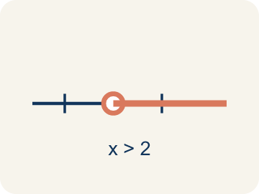 | Inequality Desigualdad  A math sentence that compares two sides with <, >, ≤, or ≥.  Example: x > 5 means x can be 6, 7, 8, ... — any number greater than 5
Greater than Mayor que
The > sign, showing one number is bigger.
Example: 8 > 3 — eight is larger than three
Less than Menor que
The < sign, showing one number is smaller.
Example: 2 < 7 — two is smaller than seven
At least / At most Al menos / A lo más
'At least' means ≥. 'At most' means ≤.
Example: 'At least 10 players' → p ≥ 10 (could be 10, 11, 12, ...); 'At most 5 tries' → t ≤ 5 (could be 5, 4, 3, ...)
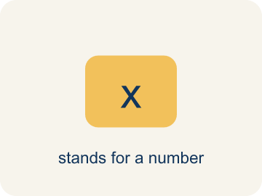 | Variable Variable  A letter that stands for an unknown number.  Example: In x > 5, the letter x stands for any number greater than 5.
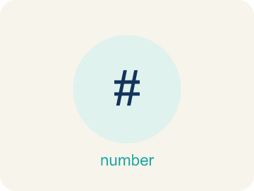 | No more than No más de  A phrase meaning less than or equal to (≤).  Example: "No more than 8 people" means people ≤ 8.

Guided Notes
Fill in each blank as we go. Use the Word Bank to help you.
WORD BANK
Inequality • Greater than • Less than • At least / At most • Variable • No more than

1. A math sentence comparing values with <, >, ≤, or ≥ is an ___.
2. The symbol > that means one value is larger than another means ___.
3. The symbol < that means one value is smaller than another means ___.
4. 'At least' means greater than or equal to, and 'at most' means ___ than or equal to.
5. A letter that stands for an unknown number is a ___.
6. The phrase that means less than or equal to is "no more than," written with the ___ symbol.

Worked Example

Watch & Read I Do — follow along with your teacher
Case File: The Suspect Constraints
Detective Navarro is narrowing down suspects. A witness says the suspect is at least 18 years old. The detective writes the inequality a ≥ 18, where a is the suspect's age. How does this help eliminate suspects?

Think about:
• What does 'at least 18' mean about the suspect's age?
• Could the suspect be exactly 18?
• How is an inequality different from an equation?
• What if the witness said the suspect was less than 30 years old?
• Could you combine two inequalities to narrow it down even more?

Solved Example I Do — watch each step
Problem: Which inequality represents: 'The temperature is less than 40 degrees'?
A) t < 40
B) t > 40
C) t ≤ 40
D) t = 40
Step 1: 'Less than' means <, so the inequality is t < 40.
Answer: A. t < 40

Guided Practice

Solve Together We Do — work with your class
Problem: Which inequality represents: 'You must be at least 48 inches tall to ride'?
A) h ≥ 48
B) h > 48
C) h < 48
D) h ≤ 48
Step 1:

Step 2:

Answer:

A detective knows the getaway car was traveling at most 65 miles per hour on the highway. The inequality s ≤ 65 represents the car's speed s.
What speeds are possible for the getaway car? How did the phrase 'at most' help you write the inequality?

Sentence frame: The car's speed could be ___ or ___ because 'at most 65' means the speed is ___ 65.

Turn & Talk discuss with a partner
1. [Launch] A witness says the suspect is 'at least 18 years old,' written as a ≥ 18. Why does the detective use an inequality here instead of an equation like a = 18?
Start with: An inequality fits better than an equation because ___.
Una desigualdad encaja mejor que una ecuación porque ___.
Word bank: inequality, greater than, less than, at least / at most
2. [Explore] How do the phrases 'at least' and 'at most' change which inequality symbol you choose compared to 'more than' and 'fewer than'?
Start with: 'At least' uses ___ because it ___ the number, but 'more than' uses ___.
'Al menos' usa ___ porque ___ el número, pero 'más que' usa ___.
Word bank: inequality, greater than, less than, at least / at most
3. [Connect] Where do you see inequalities in real life, such as age limits or speed limits?
Start with: I see an inequality when ___, and I would write ___.
Veo una desigualdad cuando ___, y escribiría ___.
Word bank: inequality, greater than, less than, at least / at most
4. [Practice] During practice on Write Inequalities, what strategy did you use when a problem felt tricky?
Start with: 'At least' uses ___ because it ___ the number, but 'more than' uses ___.
'Al menos' usa ___ porque ___ el número, pero 'más que' usa ___.
Word bank: Inequality, Greater than, Less than, At least / At most

Independent Practice

On Your Own You Do — show your work
Solve each problem. Show your thinking in the work box.
1. Which inequality represents: 'A store can hold no more than 75 people'?
A) p ≤ 75
B) p < 75
C) p ≥ 75
D) p > 75

2. Which inequality represents: 'The speed limit is more than 25 mph'?
A) s > 25
B) s ≥ 25
C) s < 25
D) s = 25

3. A parking garage charges if your stay is more than 2 hours. Which inequality represents times t that are charged?
A) t > 2
B) t ≥ 2
C) t < 2
D) t ≤ 2

4. A clue says the suspect carried at least 12 stolen gems. Which inequality shows the number g of gems?
A) g ≥ 12
B) g > 12
C) g ≤ 12
D) g < 12

Exit Ticket
Answer on your own. This shows what you learned today.
★ Which inequality represents: 'A number n is at least 14'?
A) n ≥ 14
B) n > 14
C) n ≤ 14
D) n < 14

