Write Inequalities — Homework
Lesson 7-4 • Standard 6.AT.9
Name: ______________________ Period: ______ Date: ____________

Today's Goals
Content: I can write inequalities to represent real-world situations.
Language: I can explain my inequality using the words inequality, greater than, less than, and at least / at most.

Key Words
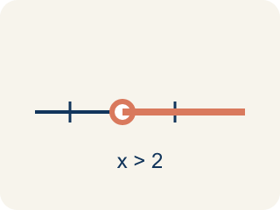
Inequality (Desigualdad) — A math sentence that compares two sides with <, >, ≤, or ≥.
Greater than (Mayor que) — The > sign, showing one number is bigger.
Less than (Menor que) — The < sign, showing one number is smaller.
At least / At most (Al menos / A lo más) — 'At least' means ≥. 'At most' means ≤.
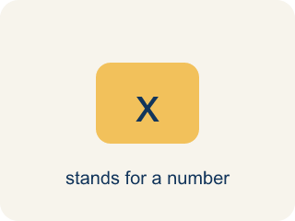
Variable (Variable) — A letter that stands for an unknown number.
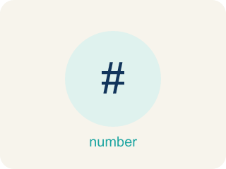
No more than (No más de) — A phrase meaning less than or equal to (≤).

Practice
Show your work. Use the blank space under each problem.
1. Which inequality represents: 'The temperature is less than 40 degrees'?
A. t < 40
B. t > 40
C. t ≤ 40
D. t = 40
______________________________________________________________________
2. Which inequality represents: 'You must be at least 48 inches tall to ride'?
A. h ≥ 48
B. h > 48
C. h < 48
D. h ≤ 48
______________________________________________________________________
3. Identify the key phrase, symbol, and write the inequality for each situation.
Situation | Key Phrase | Symbol | Inequality
A package weighs less than 50 pounds. | less than | < | w < 50
You need at least $25 to buy the game. | at least | ≥ | m ≥ 25
No more than 30 students can join the club. | no more than | ≤ | s ≤ 30
______________________________________________________________________
4. Sort each inequality into whether x = 10 is a solution.
Groups: x = 10 IS a solution | x = 10 is NOT a solution
______________________________________________________________________
5. A parking garage charges if your stay is more than 2 hours. Which inequality represents times t that are charged?
A. t > 2
B. t ≥ 2
C. t < 2
D. t ≤ 2
______________________________________________________________________
6. onLevel — Spot the Common Mistake
Step 1 (Read): A student is working on Write Inequalities.
Step 2 (Attempt): They ignored the rule: 'At least' means ≥ and 'at most' means ≤; 'more than' means > and 'fewer/less than' means <.
Step 3 (Check): The answer does not match the math rule from class.
Which step has the mistake? Explain and fix it:
______________________________________________________________________
______________________________________________________________________
______________________________________________________________________
7. Each case clue describes a boundary. Drag every scenario into the inequality symbol it matches.
Groups: > (greater than) | < (less than) | ≥ (greater than or equal to) | ≤ (less than or equal to)
• The getaway driver was going more than 70 mph → __________________
• More than 6 fingerprints were on the safe → __________________
• The ransom note was written under 3 minutes ago → __________________
• Fewer than 9 cars left the parking lot → __________________
• At least 30 dollars in coins was stolen → __________________
• No fewer than 4 witnesses saw the suspect → __________________
• At most 14 footprints were found in the mud → __________________
• No more than 7 keys can open the vault → __________________
______________________________________________________________________
8. A clue says the suspect carried at least 12 stolen gems. Which inequality shows the number g of gems?
A. g ≥ 12
B. g > 12
C. g ≤ 12
D. g < 12
______________________________________________________________________
9. A witness reports that fewer than 5 people entered the building. Which inequality shows the number n of people?
A. n < 5
B. n ≤ 5
C. n > 5
D. n ≥ 5
______________________________________________________________________
10. Match each detective clue phrase to its inequality symbol.
Item | Answer choices
____ at least | E. ≤
____ at most | D. <
____ more than | C. >
____ fewer than | B. ≤
____ no more than | A. ≥
______________________________________________________________________

Answer Key (Teacher)
1. A. t < 40
'Less than' means <, so the inequality is t < 40.
Watch for: A common mistake in Write Inequalities is skipping the key idea: "'At least' means ≥ and 'at most' means ≤; 'more than' means > and 'fewer/less than' means <." — always check your work against this rule before you submit.
2. A. h ≥ 48
'At least' means greater than or equal to, so h ≥ 48.
Watch for: A common mistake in Write Inequalities is skipping the key idea: "'At least' means ≥ and 'at most' means ≤; 'more than' means > and 'fewer/less than' means <." — always check your work against this rule before you submit.
3. Identify the key phrase, symbol, and write the inequality for each situation.
(See completed table.)

4. Correct groups:

5. A. t > 2
'More than 2 hours' means strictly greater than: t > 2. Exactly 2 hours is not charged.
Watch for: A common mistake in Write Inequalities is skipping the key idea: "'At least' means ≥ and 'at most' means ≤; 'more than' means > and 'fewer/less than' means <." — always check your work against this rule before you submit.
6. onLevel — Spot the Common Mistake
The mistake is in Step 2.
Correct work: Follow the key idea: 'At least' means ≥ and 'at most' means ≤; 'more than' means > and 'fewer/less than' means <.
7. Correct groups:
The getaway driver was going more than 70 mph → > (greater than)
More than 6 fingerprints were on the safe → > (greater than)
The ransom note was written under 3 minutes ago → < (less than)
Fewer than 9 cars left the parking lot → < (less than)
At least 30 dollars in coins was stolen → ≥ (greater than or equal to)
No fewer than 4 witnesses saw the suspect → ≥ (greater than or equal to)
At most 14 footprints were found in the mud → ≤ (less than or equal to)
No more than 7 keys can open the vault → ≤ (less than or equal to)

8. A. g ≥ 12
'At least 12' includes 12 and any number above it, so g ≥ 12.
Watch for: A common mistake in Write Inequalities is skipping the key idea: "'At least' means ≥ and 'at most' means ≤; 'more than' means > and 'fewer/less than' means <." — always check your work against this rule before you submit.
9. A. n < 5
'Fewer than 5' does not include 5, so n < 5.
Watch for: A common mistake in Write Inequalities is skipping the key idea: "'At least' means ≥ and 'at most' means ≤; 'more than' means > and 'fewer/less than' means <." — always check your work against this rule before you submit.
10. Matches:
at least → ≥
at most → ≤
more than → >
fewer than → <
no more than → ≤

