UNIT 7 · LESSON 5 STANDARD 6.EE.8

Graph Inequalities
Student Notes Packet
Name: ______________________ Date: ____________ Period: ________

Today's Goals
Content: I can graph the solutions of an inequality on a number line.
Language: I can explain my graph using the words number line, open circle, closed circle, and solution set.

Key Vocabulary
Look at the picture, read the word, then read what it means.
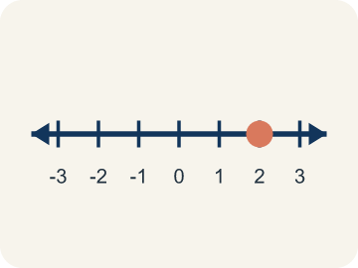 | Number line Recta numérica  A line with numbers in order. You use it to show answers.  Example: A horizontal line with marks at 0, 1, 2, 3, ... showing where values fall
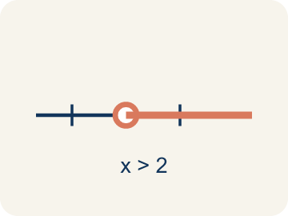 | Open circle Círculo abierto  An empty circle showing a number is NOT included.  Example: x > 5: open circle at 5 means 5 itself is NOT a solution, but 5.1, 6, 7, ... are
Closed circle Círculo cerrado
A filled-in circle showing a number IS included.
Example: x ≥ 5: closed circle at 5 means 5 IS a solution, and so are 6, 7, 8, ...
Solution set Conjunto solución
All the numbers that make the inequality true.
Example: For x > 3, the solution set includes 3.1, 4, 5, 10, 100 — any number greater than 3
Inequality Desigualdad
A math sentence comparing two amounts with <, >, ≤, or ≥.
Example: x ≥ 3 is an inequality; it is graphed as a closed circle on 3 with an arrow to the right.
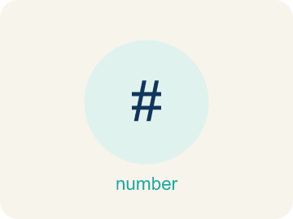 | Boundary point Punto límite  The number on the number line where the solution set starts.  Example: For x > 5, the boundary point is 5, shown with an open circle.

Guided Notes
Fill in each blank as we go. Use the Word Bank to help you.
WORD BANK
Number line • Open circle • Closed circle • Solution set • Inequality • Boundary point

1. A line with numbers in order used to show values and solutions is a ___.
2. A hollow circle that shows a value is NOT included, used for < or >, is an ___.
3. A filled-in circle that shows a value IS included, used for ≤ or ≥, is a ___.
4. All the values that make an inequality true form the ___.
5. A math sentence comparing two amounts with <, >, ≤, or ≥ is an ___.
6. The number where the solution set begins on the number line is the ___.

Worked Example

Watch & Read I Do — follow along with your teacher
Case File: The Timeline
Detective Okafor is building a timeline. The suspect was seen at the scene no earlier than 2:00 PM, meaning the arrival time t satisfies t ≥ 2. She needs to plot this on a timeline to share with her team. How should she mark the number line?

Think about:
• What does 'no earlier than 2:00 PM' mean about the time?
• Should 2:00 PM itself be included?
• Which direction on the number line would you shade?
• What would the graph look like if the suspect arrived before 2:00 PM?
• How would you show the difference between t > 2 and t ≥ 2 on a number line?

Solved Example I Do — watch each step
Problem: Which graph represents x < 5?
A) Open circle at 5, shaded left
B) Closed circle at 5, shaded left
C) Open circle at 5, shaded right
D) Closed circle at 5, shaded right
Step 1: x < 5 means 5 is NOT included (open circle) and values less than 5 are shaded (left).
Answer: A. Open circle at 5, shaded left

Guided Practice

Solve Together We Do — work with your class
Problem: Which graph represents x ≥ 3?
A) Closed circle at 3, shaded right
B) Open circle at 3, shaded right
C) Closed circle at 3, shaded left
D) Open circle at 3, shaded left
Step 1:

Step 2:

Answer:

A detective determines that fewer than 12 people were at the scene. The inequality p < 12 represents the number of people p. She graphs this with an open circle at 12 and shading to the left.
Why did the detective use an open circle instead of a closed circle? What values of p are possible?

Sentence frame: The detective used an open circle because ___ means 12 is ___ included, so possible values are numbers ___ than 12.

Turn & Talk discuss with a partner
1. [Launch] Detective Okafor knows the suspect arrived 'no earlier than 2:00 PM,' so t ≥ 2. On the timeline, should the mark at 2 be an open or closed circle, and which way should she shade?
Start with: I use a ___ circle at 2 because 2:00 ___ included.
Uso un círculo ___ en 2 porque las 2:00 ___ incluidas.
Word bank: number line, open circle, closed circle, solution set
2. [Explore] When you graphed x > 4 and x ≤ 7, why did you use an open circle on one and a closed circle on the other?
Start with: I used a ___ circle because the symbol ___ means the boundary is ___.
Usé un círculo ___ porque el símbolo ___ significa que el límite ___.
Word bank: open circle, closed circle, number line, solution set
3. [Connect] When would graphing an inequality show a real-life limit better than a single number?
Start with: A graph shows a real limit like ___ because ___.
Una gráfica muestra un límite real como ___ porque ___.
Word bank: number line, open circle, closed circle, solution set
4. [Practice] During practice on Graph Inequalities, what strategy did you use when a problem felt tricky?
Start with: I used a ___ circle because the symbol ___ means the boundary is ___.
Usé un círculo ___ porque el símbolo ___ significa que el límite ___.
Word bank: Number line, Open circle, Closed circle, Solution set

Independent Practice

On Your Own You Do — show your work
Solve each problem. Show your thinking in the work box.
1. Which graph represents x > 8?
A) Open circle at 8, shaded right
B) Closed circle at 8, shaded right
C) Open circle at 8, shaded left
D) Closed circle at 8, shaded left

2. Which graph represents x ≤ 10?
A) Closed circle at 10, shaded left
B) Open circle at 10, shaded left
C) Closed circle at 10, shaded right
D) Open circle at 10, shaded right

3. A number line shows a closed circle at 8 and is shaded to the left. Which inequality does this represent?
A) x ≤ 8
B) x < 8
C) x ≥ 8
D) x > 8

4. Clue: the witness ran more than 15 feet, so d > 15. On the number line, what do you draw?
A) Open circle at 15, shade right
B) Closed circle at 15, shade right
C) Open circle at 15, shade left
D) Closed circle at 15, shade left

Exit Ticket
Answer on your own. This shows what you learned today.
★ How would you graph the inequality x ≥ 9?
A) Closed circle at 9, shaded right
B) Open circle at 9, shaded right
C) Closed circle at 9, shaded left
D) Open circle at 9, shaded left

