Graph Inequalities — Homework
Lesson 7-5 • Standard 6.AT.9
Name: ______________________ Period: ______ Date: ____________

Today's Goals
Content: I can graph the solutions of an inequality on a number line.
Language: I can explain my graph using the words number line, open circle, closed circle, and solution set.

Key Words
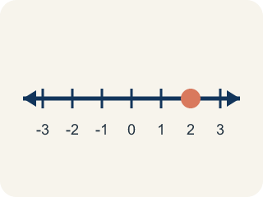
Number line (Recta numérica) — A line with numbers in order. You use it to show answers.
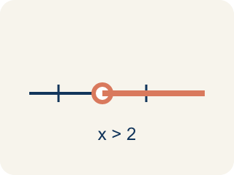
Open circle (Círculo abierto) — An empty circle showing a number is NOT included.
Closed circle (Círculo cerrado) — A filled-in circle showing a number IS included.
Solution set (Conjunto solución) — All the numbers that make the inequality true.
Inequality (Desigualdad) — A math sentence comparing two amounts with <, >, ≤, or ≥.
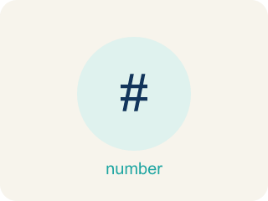
Boundary point (Punto límite) — The number on the number line where the solution set starts.

Practice
Show your work. Use the blank space under each problem.
1. Which graph represents x < 5?
A. Open circle at 5, shaded left
B. Closed circle at 5, shaded left
C. Open circle at 5, shaded right
D. Closed circle at 5, shaded right
______________________________________________________________________
2. Which graph represents x ≥ 3?
A. Closed circle at 3, shaded right
B. Open circle at 3, shaded right
C. Closed circle at 3, shaded left
D. Open circle at 3, shaded left
______________________________________________________________________
3. A number line shows a closed circle at 8 and is shaded to the left. Which inequality does this represent?
A. x ≤ 8
B. x < 8
C. x ≥ 8
D. x > 8
______________________________________________________________________
4. Complete the table comparing how different symbols affect the graph.
Inequality | Circle Type | Shade Direction | Is x = boundary a solution?
x > 6 | Open | Right | No — 6 > 6 is false
x ≥ 6 | Closed | Right | Yes — 6 ≥ 6 is true
x ≤ 6 | Closed | Left | Yes — 6 ≤ 6 is true
______________________________________________________________________
5. onLevel — Spot the Common Mistake
Step 1 (Read): A student is working on Graph Inequalities.
Step 2 (Attempt): They ignored the rule: Closed circle for ≤ or ≥ (included), open circle for < or > (not included); shade right for greater, left for less.
Step 3 (Check): The answer does not match the math rule from class.
Which step has the mistake? Explain and fix it:
______________________________________________________________________
______________________________________________________________________
______________________________________________________________________
6. Clue: the witness ran more than 15 feet, so d > 15. On the number line, what do you draw?
A. Open circle at 15, shade right
B. Closed circle at 15, shade right
C. Open circle at 15, shade left
D. Closed circle at 15, shade left
______________________________________________________________________
7. Clue: the getaway car held at most 4 suspects, so s ≤ 4. How is this graphed?
A. Closed circle at 4, shade left
B. Open circle at 4, shade left
C. Closed circle at 4, shade right
D. Open circle at 4, shade right
______________________________________________________________________
8. Detective Okafor is filing clues. Sort each inequality by the circle its graph uses.
Groups: Open circle (boundary NOT included) | Closed circle (boundary IS included)
• c > 20 → __________________
• t < 11 → __________________
• w ≥ 14 → __________________
• m ≤ 2 → __________________
______________________________________________________________________
9. Match each clue inequality to the correct graph in the case file.
Item | Answer choices
____ n > 13 | D. Open circle at 17, shaded left
____ n ≤ 16 | C. Closed circle at 20, shaded right
____ n ≥ 20 | B. Closed circle at 16, shaded left
____ n < 17 | A. Open circle at 13, shaded right
______________________________________________________________________
10. Level 2 Extension — Crack the Graphing Mistake
Step 1 (Clue inequality): k > 19 (the loot weighed more than 19 pounds)
Step 2 (Circle type): Closed circle at 19
Step 3 (Shade direction): Shade right
Step 4 (Final graph): Closed circle at 19, shaded right
Which step has the mistake? Explain and fix it:
______________________________________________________________________
______________________________________________________________________
______________________________________________________________________

Answer Key (Teacher)
1. A. Open circle at 5, shaded left
x < 5 means 5 is NOT included (open circle) and values less than 5 are shaded (left).
Watch for: A common mistake in Graph Inequalities is skipping the key idea: "Closed circle for ≤ or ≥ (included), open circle for < or > (not included); shade right for greater, left for less." — always check your work against this rule before you submit.
2. A. Closed circle at 3, shaded right
x ≥ 3 means 3 IS included (closed circle) and values greater than or equal to 3 are shaded (right).
Watch for: A common mistake in Graph Inequalities is skipping the key idea: "Closed circle for ≤ or ≥ (included), open circle for < or > (not included); shade right for greater, left for less." — always check your work against this rule before you submit.
3. A. x ≤ 8
Closed circle means the value is included (≤ or ≥). Shaded left means less than or equal to: x ≤ 8.
Watch for: A common mistake in Graph Inequalities is skipping the key idea: "Closed circle for ≤ or ≥ (included), open circle for < or > (not included); shade right for greater, left for less." — always check your work against this rule before you submit.
4. Complete the table comparing how different symbols affect the graph.
(See completed table.)

5. onLevel — Spot the Common Mistake
The mistake is in Step 2.
Correct work: Follow the key idea: Closed circle for ≤ or ≥ (included), open circle for < or > (not included); shade right for greater, left for less.
6. A. Open circle at 15, shade right
'Greater than' (>) is a strict symbol, so 15 is NOT included — open circle. Larger values work, so shade right.
Watch for: A common mistake in Graph Inequalities is skipping the key idea: "Closed circle for ≤ or ≥ (included), open circle for < or > (not included); shade right for greater, left for less." — always check your work against this rule before you submit.
7. A. Closed circle at 4, shade left
'Less than or equal to' (≤) includes 4 — closed circle. Smaller values work, so shade left.
Watch for: A common mistake in Graph Inequalities is skipping the key idea: "Closed circle for ≤ or ≥ (included), open circle for < or > (not included); shade right for greater, left for less." — always check your work against this rule before you submit.
8. Correct groups:
c > 20 → Open circle (boundary NOT included)
t < 11 → Open circle (boundary NOT included)
w ≥ 14 → Closed circle (boundary IS included)
m ≤ 2 → Closed circle (boundary IS included)

9. Matches:
n > 13 → Open circle at 13, shaded right
n ≤ 16 → Closed circle at 16, shaded left
n ≥ 20 → Closed circle at 20, shaded right
n < 17 → Open circle at 17, shaded left

10. Level 2 Extension — Crack the Graphing Mistake
The mistake is in Step 2.
Correct work: k > 19 uses the strict symbol >, so 19 is NOT a solution. The circle must be OPEN, not closed. The shading right is correct. Final graph: open circle at 19, shaded right.

