UNIT 7 · LESSON 6 STANDARD 6.EE.5

Solve and Graph Inequalities
Student Notes Packet
Name: ______________________ Date: ____________ Period: ________

Today's Goals
Content: I can solve an inequality and graph its solution set on a number line.
Language: I can explain my work using the words solve, graph, solution, and substitute.

Key Vocabulary
Look at the picture, read the word, then read what it means.
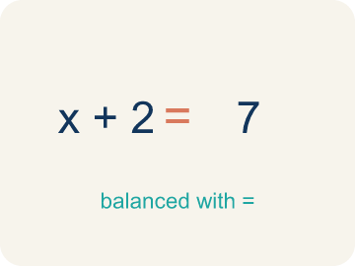 | Solve Resolver  To find the number that makes it true.  Example: x + 3 > 10 → subtract 3 → x > 7 — any number greater than 7 works
 | Graph Graficar  To show answers on a number line with circles and shading.  Example: x > 7: open circle at 7, shade right — shows all solutions at a glance
Solution Solución
A number that makes the equation or inequality true.
Example: x = 8 is a solution to x > 7 because 8 > 7 is true; x = 5 is not because 5 > 7 is false
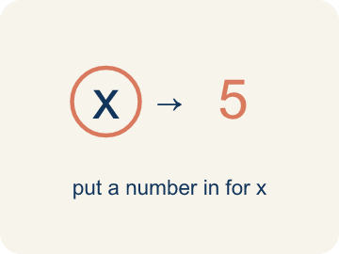 | Substitute Sustituir  To put a number in for the letter to check if it works.  Example: Substitute x = 5 into x + 3 > 10: 5 + 3 = 8, and 8 > 10 is false, so x = 5 is not a solution
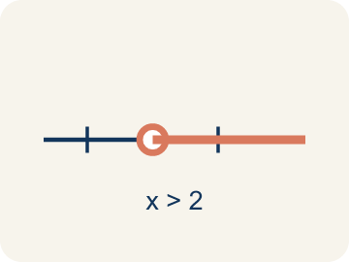 | Solution set Conjunto solución  All of the values that make an inequality true.  Example: For x > 4, the solution set is every number greater than 4, such as 5, 6, 7, ...
Inverse operation Operación inversa
An operation that undoes another, used to isolate the variable.
Example: To solve x + 3 > 7, use the inverse of adding 3: subtract 3 to get x > 4.

Guided Notes
Fill in each blank as we go. Use the Word Bank to help you.
WORD BANK
Solve • Graph • Solution • Substitute • Solution set • Inverse operation

1. To find all the values that make an inequality true is to ___ it.
2. To show the solutions on a number line is to ___ them.
3. A value that makes an inequality true is a ___.
4. To check a solution, I ___ the value back into the inequality.
5. All the values that make an inequality true form the ___.
6. An operation that undoes another to isolate the variable is an ___.

Worked Example

Watch & Read I Do — follow along with your teacher
Case File: Solve and Map It
Detective Kim knows that the suspect withdrew more than $50 from an ATM. The amount plus a $3 fee totaled more than $53. She writes x + 3 > 53 and needs to solve for x, then graph the solution set to share with the bank. How can she find and display all possible withdrawal amounts?

Think about:
• What is the unknown in this situation?
• What operation do you need to undo?
• Will the answer be one number or many numbers?
• What if the total was at most $53 instead of more than $53?
• How would the graph change if the symbol were ≥ instead of >?

Solved Example I Do — watch each step
Problem: Solve: x + 6 > 14
A) x > 8
B) x > 20
C) x < 8
D) x = 8
Step 1: Subtract 6 from both sides: x > 14 − 6 = 8.
Step 2: Graph: open circle at 8, shade right.
Answer: A. x > 8

Guided Practice

Solve Together We Do — work with your class
Problem: Solve: x − 9 ≤ 3
A) x ≤ 12
B) x ≤ 6
C) x ≥ 12
D) x = 12
Step 1:

Step 2:

Answer:

A detective needs at least $75 for a surveillance camera. She has already saved $48. The inequality 48 + s ≥ 75 represents how much more money s she needs.
How much more does the detective need? How did you solve and graph this inequality?

Sentence frame: The detective needs at least $__ more because 48 + s ≥ 75 means s ≥ 75 − ___ = ___.

Turn & Talk discuss with a partner
1. [Launch] Solving an inequality and solving an equation both isolate the variable. What is the same about your steps, and what is different about the answer you get?
Start with: The steps are the same because I ___ to ___ the variable.
Los pasos son iguales porque ___ para ___ la variable.
Word bank: solve, graph, solution, substitute
2. [Explore] What steps did you follow to solve and then graph the inequality, and how did you check a value to make sure your solution set is right?
Start with: First I solved by ___, then I graphed ___.
Primero resolví al ___, luego grafiqué ___.
Word bank: solve, graph, solution, substitute
3. [Connect] When would solving an inequality help you stay within a real-life limit?
Start with: Solving an inequality would help me stay within ___ when ___.
Resolver una desigualdad me ayudaría a quedarme dentro de ___ cuando ___.
Word bank: solve, graph, solution, substitute
4. [Practice] During practice on Solve and Graph Inequalities, what strategy did you use when a problem felt tricky?
Start with: First I solved by ___, then I graphed ___.
Primero resolví al ___, luego grafiqué ___.
Word bank: Solve, Graph, Solution, Substitute

Independent Practice

On Your Own You Do — show your work
Solve each problem. Show your thinking in the work box.
1. Solve: x + 10 ≥ 25
A) x ≥ 15
B) x ≥ 35
C) x ≤ 15
D) x = 15

2. Solve: x − 4 < 11
A) x < 15
B) x < 7
C) x > 15
D) x = 15

3. Is x = 5 a solution to x + 4 > 12?
A) No, because 5 + 4 = 9, and 9 is not greater than 12
B) Yes, because 5 + 4 = 9
C) Yes, because 5 > 4
D) No, because 5 < 12

4. Clue 1: Which value is a solution of x > 7?
A) 9
B) 7
C) 5
D) 3

Exit Ticket
Answer on your own. This shows what you learned today.
★ Solve and describe the graph: x + 5 < 11
A) x < 6; open circle at 6, shade left
B) x < 16; open circle at 16, shade left
C) x ≤ 6; closed circle at 6, shade left
D) x > 6; open circle at 6, shade right

