Solve and Graph Inequalities — Homework
Lesson 7-6 • Standard 6.AT.8
Name: ______________________ Period: ______ Date: ____________

Today's Goals
Content: I can solve an inequality and graph its solution set on a number line.
Language: I can explain my work using the words solve, graph, solution, and substitute.

Key Words
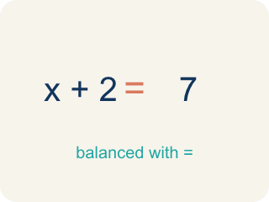
Solve (Resolver) — To find the number that makes it true.

Graph (Graficar) — To show answers on a number line with circles and shading.
Solution (Solución) — A number that makes the equation or inequality true.
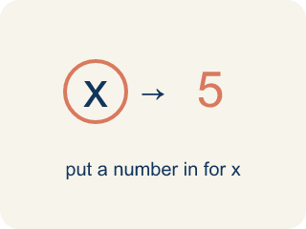
Substitute (Sustituir) — To put a number in for the letter to check if it works.
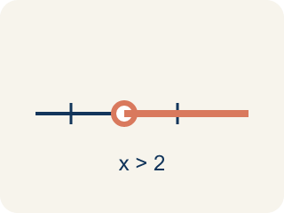
Solution set (Conjunto solución) — All of the values that make an inequality true.
Inverse operation (Operación inversa) — An operation that undoes another, used to isolate the variable.

Practice
Show your work. Use the blank space under each problem.
1. Solve: x + 6 > 14
A. x > 8
B. x > 20
C. x < 8
D. x = 8
______________________________________________________________________
2. Solve: x − 9 ≤ 3
A. x ≤ 12
B. x ≤ 6
C. x ≥ 12
D. x = 12
______________________________________________________________________
3. Solve each inequality, describe the inverse operation, and describe the graph.
Inequality | Inverse Operation | Solution | Graph Description
x + 11 ≥ 20 | Subtract 11 | x ≥ 9 | Closed circle at 9, shade right
x − 3 < 7 | Add 3 | x < 10 | Open circle at 10, shade left
x + 8 ≤ 20 | Subtract 8 | x ≤ 12 | Closed circle at 12, shade left
______________________________________________________________________
4. Is x = 5 a solution to x + 4 > 12?
A. No, because 5 + 4 = 9, and 9 is not greater than 12
B. Yes, because 5 + 4 = 9
C. Yes, because 5 > 4
D. No, because 5 < 12
______________________________________________________________________
5. Solve each inequality first, then sort by whether x = 10 is a solution.
Groups: x = 10 IS a solution | x = 10 is NOT a solution
______________________________________________________________________
6. onLevel — Spot the Common Mistake
Step 1 (Read): A student is working on Solve and Graph Inequalities.
Step 2 (Attempt): They ignored the rule: Solve with inverse operations, then graph the solution set: open circle for < or >, closed for ≤ or ≥.
Step 3 (Check): The answer does not match the math rule from class.
Which step has the mistake? Explain and fix it:
______________________________________________________________________
______________________________________________________________________
______________________________________________________________________
7. Clue 1: Which value is a solution of x > 7?
A. 9
B. 7
C. 5
D. 3
______________________________________________________________________
8. Clue 2: Is 5 a solution of x ≤ 5?
A. Yes, because 5 ≤ 5 is true
B. No, because 5 is not less than 5
C. No, because ≤ means only smaller numbers
D. Yes, but only because 5 is odd
______________________________________________________________________
9. Detective, sort each suspect's badge number into the right vault door for the rule x ≥ 4. A value is a solution if it makes x ≥ 4 true.
Groups: Solution of x ≥ 4 | NOT a solution of x ≥ 4
• 9 → __________________
• 5 → __________________
• 4 → __________________
• 3 → __________________
• 2 → __________________
• 0 → __________________
______________________________________________________________________
10. Lock-and-key match: connect each badge number to the one inequality it is a solution of. Substitute to check that each value makes its inequality true.
Item | Answer choices
____ 12 | D. x < 5
____ 6 | C. x ≥ 8
____ 8 | B. x ≤ 6
____ 3 | A. x > 10
______________________________________________________________________

Answer Key (Teacher)
1. A. x > 8
Subtract 6 from both sides: x > 14 − 6 = 8. Graph: open circle at 8, shade right.
Watch for: A common mistake in Solve and Graph Inequalities is skipping the key idea: "Solve with inverse operations, then graph the solution set: open circle for < or >, closed for ≤ or ≥." — always check your work against this rule before you submit.
2. A. x ≤ 12
Add 9 to both sides: x ≤ 3 + 9 = 12. Graph: closed circle at 12, shade left.
Watch for: A common mistake in Solve and Graph Inequalities is skipping the key idea: "Solve with inverse operations, then graph the solution set: open circle for < or >, closed for ≤ or ≥." — always check your work against this rule before you submit.
3. Solve each inequality, describe the inverse operation, and describe the graph.
(See completed table.)

4. A. No, because 5 + 4 = 9, and 9 is not greater than 12
Substitute: 5 + 4 = 9. Since 9 > 12 is false, x = 5 is NOT a solution.
Watch for: A common mistake in Solve and Graph Inequalities is skipping the key idea: "Solve with inverse operations, then graph the solution set: open circle for < or >, closed for ≤ or ≥." — always check your work against this rule before you submit.
5. Correct groups:

6. onLevel — Spot the Common Mistake
The mistake is in Step 2.
Correct work: Follow the key idea: Solve with inverse operations, then graph the solution set: open circle for < or >, closed for ≤ or ≥.
7. A. 9
A solution makes x > 7 true. Substitute each: 9 > 7 is true, but 7 > 7, 5 > 7, and 3 > 7 are all false. So 9 is the solution that opens the gate.
Watch for: A common mistake in Solve and Graph Inequalities is skipping the key idea: "Solve with inverse operations, then graph the solution set: open circle for < or >, closed for ≤ or ≥." — always check your work against this rule before you submit.
8. A. Yes, because 5 ≤ 5 is true
Substitute x = 5 into x ≤ 5: 5 ≤ 5 is true because ≤ means 'less than OR equal to.' The boundary value 5 IS a solution, so the gate opens.
Watch for: A common mistake in Solve and Graph Inequalities is skipping the key idea: "Solve with inverse operations, then graph the solution set: open circle for < or >, closed for ≤ or ≥." — always check your work against this rule before you submit.
9. Correct groups:
9 → Solution of x ≥ 4
5 → Solution of x ≥ 4
4 → Solution of x ≥ 4
3 → NOT a solution of x ≥ 4
2 → NOT a solution of x ≥ 4
0 → NOT a solution of x ≥ 4

10. Matches:
12 → x > 10
6 → x ≤ 6
8 → x ≥ 8
3 → x < 5

