UNIT 7 · LESSON 7 STANDARD 6.EE.7

Equations and Inequalities Problem Solving
Student Notes Packet
Name: ______________________ Date: ____________ Period: ________

Today's Goals
Content: I can model and solve real-world problems using equations and inequalities.
Language: I can explain my reasoning using the words model, equation, inequality, and reasonableness.

Key Vocabulary
Look at the picture, read the word, then read what it means.
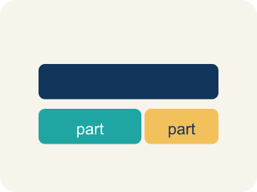 | Model Modelar  To show a real-life situation with an equation or inequality.  Example: 'Twice a number is 18' → 2n = 18 — the equation models the words
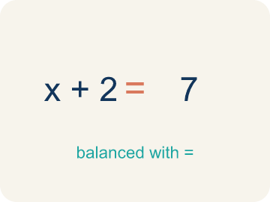 | Equation Ecuación  A math sentence with an equal sign showing both sides are the same.  Example: x + 5 = 12 — exactly one answer: x = 7
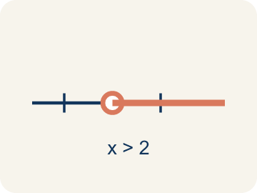 | Inequality Desigualdad  A math sentence that compares two sides with <, >, ≤, or ≥.  Example: x + 5 > 12 — many answers: x = 8, 9, 10, ...
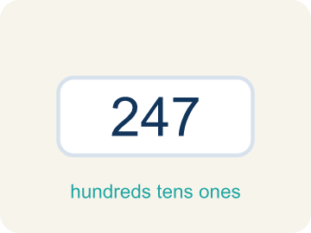 | Reasonableness Razonabilidad  Checking if your answer makes sense.  Example: If the problem asks for a number of people and you get x = −3, that is NOT reasonable
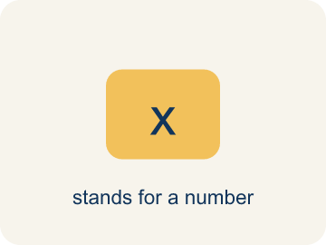 | Variable Variable  A letter that stands for the unknown amount in a word problem.  Example: "5 less than a number is 12" becomes x − 5 = 12, where x is the variable.
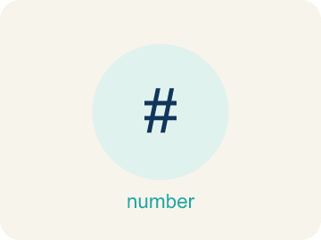 | Constraint Restricción  A limit in a problem that tells what values are allowed.  Example: "You can spend at most $20" is a constraint: cost ≤ 20.

Guided Notes
Fill in each blank as we go. Use the Word Bank to help you.
WORD BANK
Model • Equation • Inequality • Reasonableness • Variable • Constraint

1. A drawing, equation, or diagram that represents a situation is a ___.
2. A math sentence with an equal sign is an ___.
3. A math sentence that compares values with <, >, ≤, or ≥ is an ___.
4. Checking whether an answer makes sense for the problem is checking its ___.
5. A letter that stands for the unknown amount in a problem is a ___.
6. A limit that tells which values are allowed in a problem is a ___.

Worked Example

Watch & Read I Do — follow along with your teacher
Case File: The Final Puzzle
Detective Santos is closing a complex case. She has collected equations and inequalities from different parts of the investigation. One clue says: 'The total value of stolen items divided equally among 4 accomplices gave each person $85.' Another says: 'The lookout earned less than $50.' She must model both clues mathematically and check if the answers are reasonable. Can you help?

Think about:
• Which clue leads to an equation and which leads to an inequality?
• What operation does 'divided equally among 4' suggest?
• What does 'less than $50' tell you about the inequality symbol?
• How do you decide when to use an equation versus an inequality?
• What would happen if the lookout earned exactly $50 — would the clue still work?

Solved Example I Do — watch each step
Problem: A museum has some paintings. After adding 12, they have 45. Which equation models this?
A) p + 12 = 45
B) p − 12 = 45
C) 12p = 45
D) p / 12 = 45
Step 1: 'Adding 12' to the original number gives 45: p + 12 = 45.
Step 2: Solve: p = 33.
Answer: A. p + 12 = 45

Guided Practice

Solve Together We Do — work with your class
Problem: A detective needs more than 8 hours to finish the investigation. She has already worked 3 hours. Which inequality represents the additional hours h she needs?
A) 3 + h > 8
B) 3 + h = 8
C) h > 3
D) 8 + h > 3
Step 1:

Step 2:

Answer:

A detective has a $500 budget for equipment. She has already spent $320. The inequality 320 + r ≤ 500 represents the remaining amount r she can spend. She also needs exactly 4 flashlights at $15 each, represented by the equation 4f = 60.
How much more can the detective spend? How much does each flashlight cost? When do you use an equation versus an inequality?

Sentence frame: The detective can spend at most $__ more because r ≤ 500 − ___ = ___. Each flashlight costs $__ because f = 60 ÷ ___ = ___.

Turn & Talk discuss with a partner
1. [Launch] Before solving a word problem, how do you decide whether to model it with an equation or an inequality?
Start with: I would model this with a(n) ___ because the problem says ___.
Modelaría esto con un(a) ___ porque el problema dice ___.
Word bank: model, equation, inequality, reasonableness
2. [Explore] What was your plan to solve this problem, and how did you check that your answer was reasonable?
Start with: My plan was to ___, and I knew to ___ because ___.
Mi plan fue ___, y supe ___ porque ___.
Word bank: model, equation, inequality, reasonableness
3. [Connect] Describe a real situation that an equation or inequality could model, and explain which one you would use.
Start with: A real situation is ___, which I would model with a(n) ___.
Una situación real es ___, que modelaría con un(a) ___.
Word bank: model, equation, inequality, reasonableness
4. [Practice] During practice on Equations and Inequalities Problem Solving, what strategy did you use when a problem felt tricky?
Start with: My plan was to ___, and I knew to ___ because ___.
Mi plan fue ___, y supe ___ porque ___.
Word bank: Model, Equation, Inequality, Reasonableness

Independent Practice

On Your Own You Do — show your work
Solve each problem. Show your thinking in the work box.
1. Which model is correct for: 'A number divided by 6 equals 7'?
A) n / 6 = 7
B) 6n = 7
C) n − 6 = 7
D) n + 6 = 7

2. A bus can carry at most 48 passengers. There are already 31 on board. Which inequality shows how many more can board?
A) 31 + p ≤ 48
B) 31 + p > 48
C) 31 + p = 48
D) p − 31 ≤ 48

3. A student solved 4n = 52 and got n = 13. Is the answer reasonable if n represents the number of notebooks in a box?
A) Yes — 13 notebooks per box is reasonable
B) No — 13 is too many notebooks
C) No — the answer should be 48
D) Yes — but only if n is a fraction

4. Room 2: The vault keypad clue reads, 'A number of stolen coins plus 6 equals 14.' Solve x + 6 = 14 to find the code x.
A) x = 8
B) x = 20
C) x = 6
D) x = 2

Exit Ticket
Answer on your own. This shows what you learned today.
★ A box of donuts has some donuts. After giving away 7, there are fewer than 5 left. Which inequality represents the starting number of donuts d?
A) d − 7 < 5
B) d + 7 < 5
C) d − 7 > 5
D) d − 7 = 5

