Equations and Inequalities Problem Solving — Homework
Lesson 7-7 • Standard 6.AT.8
Name: ______________________ Period: ______ Date: ____________

Today's Goals
Content: I can model and solve real-world problems using equations and inequalities.
Language: I can explain my reasoning using the words model, equation, inequality, and reasonableness.

Key Words
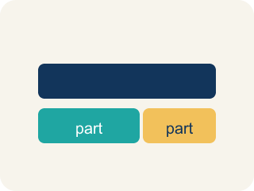
Model (Modelar) — To show a real-life situation with an equation or inequality.
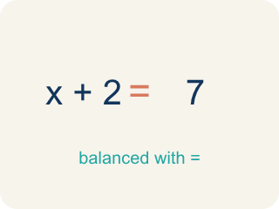
Equation (Ecuación) — A math sentence with an equal sign showing both sides are the same.
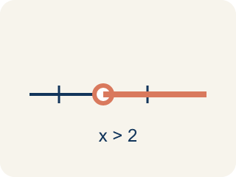
Inequality (Desigualdad) — A math sentence that compares two sides with <, >, ≤, or ≥.
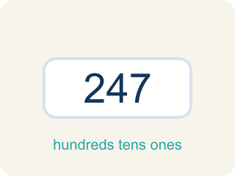
Reasonableness (Razonabilidad) — Checking if your answer makes sense.
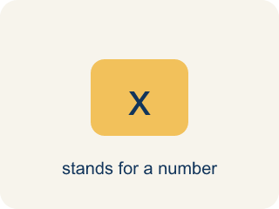
Variable (Variable) — A letter that stands for the unknown amount in a word problem.
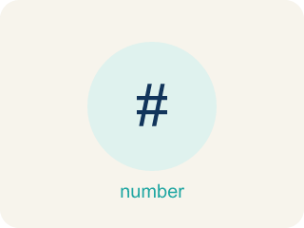
Constraint (Restricción) — A limit in a problem that tells what values are allowed.

Practice
Show your work. Use the blank space under each problem.
1. A museum has some paintings. After adding 12, they have 45. Which equation models this?
A. p + 12 = 45
B. p − 12 = 45
C. 12p = 45
D. p / 12 = 45
______________________________________________________________________
2. A detective needs more than 8 hours to finish the investigation. She has already worked 3 hours. Which inequality represents the additional hours h she needs?
A. 3 + h > 8
B. 3 + h = 8
C. h > 3
D. 8 + h > 3
______________________________________________________________________
3. Write a model, solve, and check reasonableness for each problem.
Word Problem | Model | Solution | Reasonable?
Five identical boxes weigh a total of 60 pounds. How much does each box weigh? | 5w = 60 | w = 12 pounds | Yes — 12 pounds per box is reasonable.
A shelf can hold at most 30 books. There are already 17 books. How many more can be added? | 17 + b ≤ 30 | b ≤ 13 books | Yes — up to 13 more books fits.
A baker split 84 cookies equally into bags of 12. How many bags did she use? | 12b = 84 | b = 7 bags | Yes — 7 bags of 12 = 84 cookies.
______________________________________________________________________
4. A student solved 4n = 52 and got n = 13. Is the answer reasonable if n represents the number of notebooks in a box?
A. Yes — 13 notebooks per box is reasonable
B. No — 13 is too many notebooks
C. No — the answer should be 48
D. Yes — but only if n is a fraction
______________________________________________________________________
5. onLevel — Spot the Common Mistake
Step 1 (Read): A student is working on Equations and Inequalities Problem Solving.
Step 2 (Attempt): They ignored the rule: 'Equals' or 'exactly' points to an equation (=); 'at least, at most, more than, fewer than' points to an inequality.
Step 3 (Check): The answer does not match the math rule from class.
Which step has the mistake? Explain and fix it:
______________________________________________________________________
______________________________________________________________________
______________________________________________________________________
6. Room 1: The case board is a mess. Sort each clue into whether it needs an EQUATION (one exact total) or an INEQUALITY (a limit or range).
Groups: Needs an Equation (=) | Needs an Inequality (<, >, ≤, ≥)
• The ransom was split equally among 5 suspects, giving each $40. → __________________
• A number of fingerprints plus 9 equals 21. → __________________
• The getaway car held no more than 6 bags of loot. → __________________
• The alarm must stay on for at least 30 minutes. → __________________
• The witness saw fewer than 4 accomplices. → __________________
• Three identical safes hold exactly 75 coins in all. → __________________
______________________________________________________________________
7. Room 2: The vault keypad clue reads, 'A number of stolen coins plus 6 equals 14.' Solve x + 6 = 14 to find the code x.
A. x = 8
B. x = 20
C. x = 6
D. x = 2
______________________________________________________________________
8. Room 3: A sign warns, 'The safe holds at most 20 gold bars.' Which inequality models the number of bars x?
A. x ≤ 20
B. x ≥ 20
C. x > 20
D. x = 20
______________________________________________________________________
9. Room 4: A locked drawer clue reads, 'Five identical evidence boxes weigh 60 pounds in all.' Solve 5w = 60 for each box's weight w.
A. w = 12
B. w = 55
C. w = 300
D. w = 65
______________________________________________________________________
10. Room 5: Match each crime-scene clue to the model the detective should write.
Item | Answer choices
____ The reward divided among 4 detectives gave each $50. | D. f ≥ 25
____ A number of clues take away 7 leaves exactly 9. | C. h > 8
____ The patrol must last more than 8 hours. | B. c − 7 = 9, so c = 16
____ The locker holds at least 25 files. | A. 4d = 200, so d = 50
______________________________________________________________________

Answer Key (Teacher)
1. A. p + 12 = 45
'Adding 12' to the original number gives 45: p + 12 = 45. Solve: p = 33.
Watch for: A common mistake in Equations and Inequalities Problem Solving is skipping the key idea: "'Equals' or 'exactly' points to an equation (=); 'at least, at most, more than, fewer than' points to an inequality." — always check your work against this rule before you submit.
2. A. 3 + h > 8
3 hours plus additional hours h must be more than 8: 3 + h > 8. Solve: h > 5.
Watch for: A common mistake in Equations and Inequalities Problem Solving is skipping the key idea: "'Equals' or 'exactly' points to an equation (=); 'at least, at most, more than, fewer than' points to an inequality." — always check your work against this rule before you submit.
3. Write a model, solve, and check reasonableness for each problem.
(See completed table.)

4. A. Yes — 13 notebooks per box is reasonable
4 × 13 = 52 ✓. 13 notebooks per box is a reasonable whole number answer.
Watch for: A common mistake in Equations and Inequalities Problem Solving is skipping the key idea: "'Equals' or 'exactly' points to an equation (=); 'at least, at most, more than, fewer than' points to an inequality." — always check your work against this rule before you submit.
5. onLevel — Spot the Common Mistake
The mistake is in Step 2.
Correct work: Follow the key idea: 'Equals' or 'exactly' points to an equation (=); 'at least, at most, more than, fewer than' points to an inequality.
6. Correct groups:
The ransom was split equally among 5 suspects, giving each $40. → Needs an Equation (=)
A number of fingerprints plus 9 equals 21. → Needs an Equation (=)
The getaway car held no more than 6 bags of loot. → Needs an Inequality (<, >, ≤, ≥)
The alarm must stay on for at least 30 minutes. → Needs an Inequality (<, >, ≤, ≥)
The witness saw fewer than 4 accomplices. → Needs an Inequality (<, >, ≤, ≥)
Three identical safes hold exactly 75 coins in all. → Needs an Equation (=)

7. A. x = 8
Subtract 6 from both sides: x = 14 − 6 = 8. Check: 8 + 6 = 14 ✓
Watch for: A common mistake in Equations and Inequalities Problem Solving is skipping the key idea: "'Equals' or 'exactly' points to an equation (=); 'at least, at most, more than, fewer than' points to an inequality." — always check your work against this rule before you submit.
8. A. x ≤ 20
'At most 20' means 20 or fewer, so x ≤ 20.
Watch for: A common mistake in Equations and Inequalities Problem Solving is skipping the key idea: "'Equals' or 'exactly' points to an equation (=); 'at least, at most, more than, fewer than' points to an inequality." — always check your work against this rule before you submit.
9. A. w = 12
Divide both sides by 5: w = 60 ÷ 5 = 12 pounds. Check: 5 × 12 = 60 ✓
Watch for: A common mistake in Equations and Inequalities Problem Solving is skipping the key idea: "'Equals' or 'exactly' points to an equation (=); 'at least, at most, more than, fewer than' points to an inequality." — always check your work against this rule before you submit.
10. Matches:
The reward divided among 4 detectives gave each $50. → 4d = 200, so d = 50
A number of clues take away 7 leaves exactly 9. → c − 7 = 9, so c = 16
The patrol must last more than 8 hours. → h > 8
The locker holds at least 25 files. → f ≥ 25

