Statistical Questions and Data — Homework
Lesson 8-1 • Standard 6.DS.1
Name: ______________________ Period: ______ Date: ____________

Today's Goals
Content: I can tell the difference between a statistical question and a non-statistical question.
Language: I can explain my reasoning using the words statistical question, data, variability, and survey.

Key Words
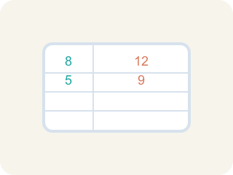
Statistical Question (Pregunta estadística) — A question where the answers will be different for different people.
Data (Datos) — Facts and numbers you collect, like answers to a survey.
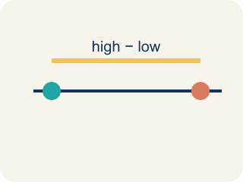
Variability (Variabilidad) — How spread out the numbers are.
Survey (Encuesta) — Collecting facts by asking people questions.
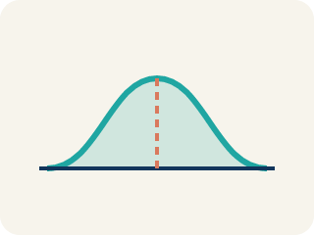
Data distribution (Distribución de datos) — How the data looks: where it sits and how spread out it is.

Practice
Show your work. Use the blank space under each problem.
1. Which of the following is a statistical question?
A. How many points did each player score this season?
B. How many points are scored for a free throw?
C. What sport does this team play?
D. How many halves are in a soccer game?
______________________________________________________________________
2. Which question is NOT a statistical question?
A. How many innings are in a baseball game?
B. How many home runs did each player hit this year?
C. How many miles does each runner train per week?
D. How tall is each player on the basketball team?
______________________________________________________________________
3. A coach asks: "How many hours does each athlete on the track team sleep the night before a meet?" Why is this a statistical question?
A. Because the answers will vary from athlete to athlete
B. Because it is about sports
C. Because it has a numerical answer
D. Because the coach asked it
______________________________________________________________________
4. Decide if each question is statistical and explain why.
Question | Statistical? | Why?
How many push-ups can each student do in one minute? | Yes | Different students can do different amounts — there is variability.
How many sides does a basketball court have? | No | There is one fixed answer (4 sides) — no variability.
How far does each player kick the ball? | Yes | Different players kick different distances — the data varies.
______________________________________________________________________
5. Each non-statistical question below has been rewritten to become statistical. Match the original to its rewritten version.
Groups: Original: 'How many students are in 6th grade?' | Original: 'What time does school start?'
______________________________________________________________________
6. onLevel — Spot the Common Mistake
Step 1 (Read): A student is working on Statistical Questions and Data.
Step 2 (Attempt): They ignored the rule: If you expect the answers to vary, it is a statistical question.
Step 3 (Check): The answer does not match the math rule from class.
Which step has the mistake? Explain and fix it:
______________________________________________________________________
______________________________________________________________________
______________________________________________________________________
7. Drag each scouting question into the right bin. A statistical question expects answers that VARY from player to player; a non-statistical question has one fixed answer.
Groups: Statistical | Not Statistical
• How many push-ups can each player on the team do in one minute? → __________________
• How many points does each starter average per game? → __________________
• How many seconds does each player take to sprint the court? → __________________
• How many free throws did each teammate make in practice? → __________________
• How many players are allowed on the court at once? → __________________
• What is the diameter of an official basketball hoop? → __________________
• How many quarters are played in one game? → __________________
______________________________________________________________________
8. The team analyst writes four questions for the scouting report. Which one is a statistical question?
A. How many rebounds does each player grab per game?
B. How many points is a single free throw worth?
C. What is the height of the basketball rim?
D. How many timeouts does each team get per half?
______________________________________________________________________
9. Why does the question "How many minutes did each athlete warm up before the game?" count as a statistical question?
A. Because the warm-up times will vary from one athlete to another
B. Because the answer is measured in minutes
C. Because every athlete warmed up for exactly the same time
D. Because it is about a sports team
______________________________________________________________________
10. Match each weak (non-statistical) scouting question to a stronger version that becomes statistical by adding variability.
Item | Answer choices
____ How many players are on the roster? | D. How many points did each player score in the game?
____ What time does the game start? | C. How far from the hoop does each player shoot most often?
____ How long is the basketball court? | B. What time does each fan arrive at the arena?
____ How many points did the team score in total? | A. How many minutes does each player on the roster play per game?
______________________________________________________________________

Answer Key (Teacher)
1. A. How many points did each player score this season?
"How many points did each player score?" is statistical because different players will have different scores — there is variability in the data.
Watch for: A common mistake in Statistical Questions and Data is skipping the key idea: "If you expect the answers to vary, it is a statistical question." — always check your work against this rule before you submit.
2. A. How many innings are in a baseball game?
"How many innings are in a baseball game?" has one fixed answer (9) — no variability. The other questions all produce different answers for different people.
Watch for: A common mistake in Statistical Questions and Data is skipping the key idea: "If you expect the answers to vary, it is a statistical question." — always check your work against this rule before you submit.
3. A. Because the answers will vary from athlete to athlete
A statistical question anticipates variability. Different athletes sleep different amounts, so the data collected will vary.
Watch for: A common mistake in Statistical Questions and Data is skipping the key idea: "If you expect the answers to vary, it is a statistical question." — always check your work against this rule before you submit.
4. Decide if each question is statistical and explain why.
(See completed table.)

5. Correct groups:

6. onLevel — Spot the Common Mistake
The mistake is in Step 2.
Correct work: Follow the key idea: If you expect the answers to vary, it is a statistical question.
7. Correct groups:
How many push-ups can each player on the team do in one minute? → Statistical
How many points does each starter average per game? → Statistical
How many seconds does each player take to sprint the court? → Statistical
How many free throws did each teammate make in practice? → Statistical
How many players are allowed on the court at once? → Not Statistical
What is the diameter of an official basketball hoop? → Not Statistical
How many quarters are played in one game? → Not Statistical

8. A. How many rebounds does each player grab per game?
"How many rebounds does each player grab per game?" anticipates variability — different players grab different numbers of rebounds, so you must collect data. The other three each have one fixed answer.
Watch for: A common mistake in Statistical Questions and Data is skipping the key idea: "If you expect the answers to vary, it is a statistical question." — always check your work against this rule before you submit.
9. A. Because the warm-up times will vary from one athlete to another
A statistical question anticipates variability. Different athletes warm up for different amounts of time, so the data you collect will vary.
Watch for: A common mistake in Statistical Questions and Data is skipping the key idea: "If you expect the answers to vary, it is a statistical question." — always check your work against this rule before you submit.
10. Matches:
How many players are on the roster? → How many minutes does each player on the roster play per game?
What time does the game start? → What time does each fan arrive at the arena?
How long is the basketball court? → How far from the hoop does each player shoot most often?
How many points did the team score in total? → How many points did each player score in the game?

