Mean, Median, and Mode — Homework
Lesson 8-2 • Standard 6.DS.4
Name: ______________________ Period: ______ Date: ____________

Today's Goals
Content: I can find the mean, median, and mode of a data set.
Language: I can explain my reasoning using the words mean, median, mode, and outlier.

Key Words
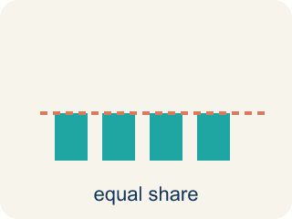
Mean (Media) — The average. Add all the numbers, then divide by how many there are.
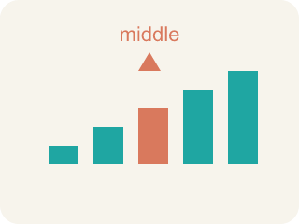
Median (Mediana) — The middle number when you put them in order.
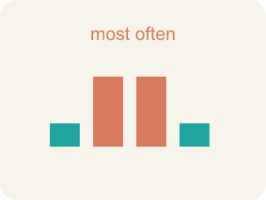
Mode (Moda) — The number that shows up most often.
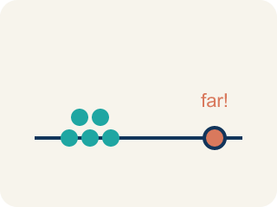
Outlier (Valor atípico) — A number that is much bigger or smaller than the rest.
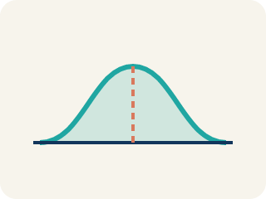
Data distribution (Distribución de datos) — How the data looks: where it sits and how spread out it is.
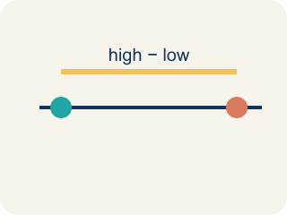
Variability (Variabilidad) — How spread out the numbers are.

Practice
Show your work. Use the blank space under each problem.
1. Find the mean of: 10, 14, 8, 12, 16
A. 12
B. 14
C. 10
D. 60
______________________________________________________________________
2. Find the median of: 3, 7, 2, 9, 5
A. 5
B. 3
C. 7
D. 5.2
______________________________________________________________________
3. Complete the table.
Data Set | Mean | Median | Mode
5, 8, 8, 10, 14
20, 25, 25, 30, 25, 35
100, 110, 90, 100, 115, 95
______________________________________________________________________
4. Match each measure to its definition.
Item | Answer choices
____ Mean | D. Max − Min
____ Median | C. Most frequent
____ Mode | B. Middle value
____ Range | A. Sum ÷ Count
______________________________________________________________________
5. Data set: 4, 6, 6, 8, 10, 12. What is the median?
A. 7
B. 6
C. 8
D. 7.67
______________________________________________________________________
6. onLevel — Spot the Common Mistake
Step 1 (Read): A student is working on Mean, Median, and Mode.
Step 2 (Attempt): They ignored the rule: Mean = add then divide, median = the middle of the ordered numbers, mode = the value that shows up most.
Step 3 (Check): The answer does not match the math rule from class.
Which step has the mistake? Explain and fix it:
______________________________________________________________________
______________________________________________________________________
______________________________________________________________________
7. A player scored 4, 8, 6, 10, and 2 points across five quarters. What is the MEAN number of points?
A. 6
B. 8
C. 30
D. 10
______________________________________________________________________
8. A goalie made 3, 7, 9, 2, and 5 saves in five games. What is the MEDIAN number of saves?
A. 5
B. 9
C. 7
D. 2
______________________________________________________________________
9. A team scored 4, 4, 7, and 9 goals in four matches. What is the MODE?
A. 4
B. 7
C. 9
D. 6
______________________________________________________________________
10. Match each sports data set to the value of the measure named in CAPITALS.
Item | Answer choices
____ Game points 9, 3, 7, 5, 6 → MEAN | D. 14
____ Rebounds 8, 3, 11, 6, 1 → MEDIAN | C. 6
____ Jersey numbers 6, 2, 6, 9, 6, 3 → MODE | B. 6
____ Assists 14, 10, 18, 12, 16 → MEAN | A. 6
______________________________________________________________________

Answer Key (Teacher)
1. A. 12
Sum = 10 + 14 + 8 + 12 + 16 = 60. Mean = 60 ÷ 5 = 12.
Watch for: A common mistake in Mean, Median, and Mode is skipping the key idea: "Mean = add then divide, median = the middle of the ordered numbers, mode = the value that shows up most." — always check your work against this rule before you submit.
2. A. 5
Ordered: 2, 3, 5, 7, 9. The middle value is 5.
Watch for: A common mistake in Mean, Median, and Mode is skipping the key idea: "Mean = add then divide, median = the middle of the ordered numbers, mode = the value that shows up most." — always check your work against this rule before you submit.
3. Table
5, 8, 8, 10, 14 — Mean: 9
5, 8, 8, 10, 14 — Median: 8
5, 8, 8, 10, 14 — Mode: 8
20, 25, 25, 30, 25, 35 — Mean: 26.67
20, 25, 25, 30, 25, 35 — Median: 25
20, 25, 25, 30, 25, 35 — Mode: 25
100, 110, 90, 100, 115, 95 — Mean: 101.67
100, 110, 90, 100, 115, 95 — Median: 100
100, 110, 90, 100, 115, 95 — Mode: 100

4. Matches:
Mean → Sum ÷ Count
Median → Middle value
Mode → Most frequent
Range → Max − Min

5. A. 7
With 6 values, the median is the average of the 3rd and 4th values: (6 + 8) ÷ 2 = 7.
Watch for: A common mistake in Mean, Median, and Mode is skipping the key idea: "Mean = add then divide, median = the middle of the ordered numbers, mode = the value that shows up most." — always check your work against this rule before you submit.
6. onLevel — Spot the Common Mistake
The mistake is in Step 2.
Correct work: Follow the key idea: Mean = add then divide, median = the middle of the ordered numbers, mode = the value that shows up most.
7. A. 6
Add the points: 4 + 8 + 6 + 10 + 2 = 30. Divide by 5 quarters: 30 ÷ 5 = 6.
Watch for: A common mistake in Mean, Median, and Mode is skipping the key idea: "Mean = add then divide, median = the middle of the ordered numbers, mode = the value that shows up most." — always check your work against this rule before you submit.
8. A. 5
Order the saves first: 2, 3, 5, 7, 9. The middle (3rd) value is 5, so the median is 5.
Watch for: A common mistake in Mean, Median, and Mode is skipping the key idea: "Mean = add then divide, median = the middle of the ordered numbers, mode = the value that shows up most." — always check your work against this rule before you submit.
9. A. 4
The mode is the value that appears most often. 4 shows up twice; every other value appears once. So the mode is 4.
Watch for: A common mistake in Mean, Median, and Mode is skipping the key idea: "Mean = add then divide, median = the middle of the ordered numbers, mode = the value that shows up most." — always check your work against this rule before you submit.
10. Matches:
Game points 9, 3, 7, 5, 6 → MEAN → 6
Rebounds 8, 3, 11, 6, 1 → MEDIAN → 6
Jersey numbers 6, 2, 6, 9, 6, 3 → MODE → 6
Assists 14, 10, 18, 12, 16 → MEAN → 14

