UNIT 8 · LESSON 3 STANDARD 6.SP.5C

Mean Absolute Deviation
Student Notes Packet
Name: ______________________ Date: ____________ Period: ________

Today's Goals
Content: I can find the mean absolute deviation (MAD) to describe how spread out data is.
Language: I can explain my work using the words mean absolute deviation, deviation, absolute value, and spread.

Key Vocabulary
Look at the picture, read the word, then read what it means.
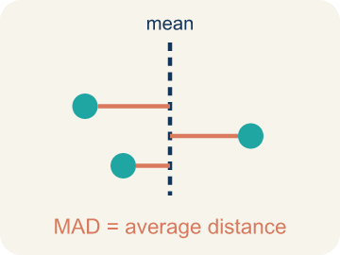 | Mean Absolute Deviation Desviación media absoluta  The average distance of each number from the mean.  Example: Data: 8, 10, 12. Mean = 10. Distances from mean: 2, 0, 2. MAD = (2+0+2) ÷ 3 = 1.33
Deviation Desviación
How far a number is from the mean.
Example: If mean = 20 and value = 17, deviation = 17 − 20 = −3 (3 below the mean)
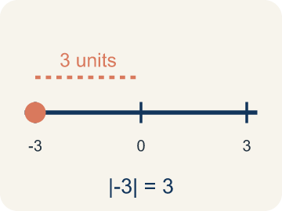 | Absolute Value Valor absoluto  How far a number is from zero. It is always positive.  Example: |−3| = 3 and |3| = 3 — both are 3 units from zero
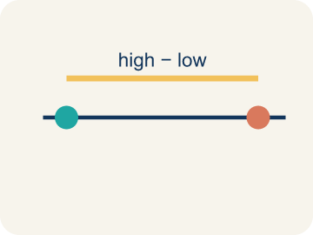 | Spread Dispersión  How far apart the numbers are.  Example: Low spread: 8, 9, 10, 11 (close together). High spread: 2, 9, 10, 25 (far apart)
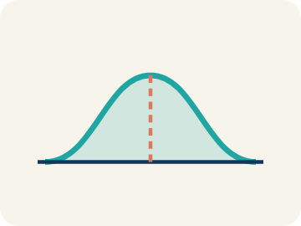 | Data distribution Distribución de datos  How the data looks: where it sits and how spread out it is.  Example: A set clustered tightly around the mean has low MAD; a set spread far from the mean has high MAD
Variability Variabilidad
How spread out the numbers are.
Example: Low variability (MAD = 1): very consistent. High variability (MAD = 8): very spread out

Guided Notes
Fill in each blank as we go. Use the Word Bank to help you.
WORD BANK
Mean Absolute Deviation • Deviation • Absolute Value • Spread • Data distribution • Variability

1. The average distance of each value from the mean is the ___.
2. How far a single value is from the mean is its ___.
3. The distance of a number from zero, always positive, is its ___.
4. How far apart the data values are from each other is the ___.
5. The way data values are spread out is the ___.
6. How much the data values differ is the ___.

Worked Example

Watch & Read I Do — follow along with your teacher
Player Consistency Report
Coach wants to know which basketball player is more consistent: Player A scored 18, 22, 20, 24, 16 points in the last 5 games. Player B scored 10, 30, 25, 12, 23 points. Both players average 20 points per game. Which player would you count on to score close to 20 every night?

Think about:
• Both players have the same mean. What is different about their scores?
• Which player's scores stay closer to 20?
• Which player has the biggest single-game difference from 20?
• How can we measure how spread out each player's scores are?
• Is there a number that tells us which player is more consistent?

Solved Example I Do — watch each step
Problem: The mean of a data set is 15. One value is 11. What is the absolute deviation of that value from the mean?
A) 4
B) −4
C) 26
D) 11
Step 1: Deviation = 11 − 15 = −4.
Step 2: Absolute deviation = |−4| = 4.
Answer: A. 4

Guided Practice

Solve Together We Do — work with your class
Problem: A data set has absolute deviations of 3, 1, 5, 2, 4. What is the MAD?
A) 3
B) 5
C) 15
D) 1
Step 1:

Step 2:

Answer:

Two soccer goalkeepers track goals allowed per game over 6 games. Keeper A: 1, 2, 1, 3, 2, 1 (mean = 1.67, MAD ≈ 0.56). Keeper B: 0, 4, 1, 3, 0, 2 (mean = 1.67, MAD ≈ 1.22). The coach needs to pick a starter for the championship game.
Both keepers allow the same average goals. Which should the coach pick and why?

Sentence frame: Both keepers have a mean of ___. Keeper A's MAD is ___, which means ___. Keeper B's MAD is ___, which means ___. The coach should pick ___ because ___.

Turn & Talk discuss with a partner
1. [Launch] Player A scored 18, 22, 20, 24, 16 and Player B scored 10, 30, 25, 12, 23. Both average 20. Which player would you count on to score close to 20 every night, and why?
Start with: I would count on Player ___ because their scores are ___.
Contaría con el Jugador ___ porque sus puntajes están ___.
Word bank: mean absolute deviation, deviation, spread, consistent, mean
2. [Explore] To find the MAD for Player A (18, 22, 20, 24, 16, mean 20), why do we take the ABSOLUTE VALUE of each deviation before averaging?
Start with: We use absolute value so the deviations are all ___.
Usamos el valor absoluto para que las desviaciones sean todas ___.
Word bank: mean absolute deviation, deviation, absolute value, spread, mean
3. [Connect] Two keepers both allow a mean of 1.67 goals, but Keeper A's MAD is 0.56 and Keeper B's is 1.22. Which keeper should the coach start in the championship, and why?
Start with: The coach should pick Keeper ___ because their MAD is ___.
El entrenador debe elegir al Portero ___ porque su DAM es ___.
Word bank: mean absolute deviation, deviation, spread, consistent, mean
4. [Reflect] For the data set 4, 8, 6, 10, 2 with a mean of 6, talk through the steps to find the MAD.
Start with: First I find each deviation from 6, then take the ___.
Primero hallo cada desviación de 6, luego tomo el ___.
Word bank: mean absolute deviation, deviation, absolute value, spread, average
5. [Practice] During practice on Mean Absolute Deviation, what strategy did you use when a problem felt tricky?
Start with: We use absolute value so the deviations are all ___.
Usamos el valor absoluto para que las desviaciones sean todas ___.
Word bank: Mean Absolute Deviation, Deviation, Absolute Value, Spread

Independent Practice

On Your Own You Do — show your work
Solve each problem. Show your thinking in the work box.
1. The mean of a data set is 20. A value is 26. What is the absolute deviation?
A) 6
B) −6
C) 46
D) 26

2. Team A has MAD = 2.1 points. Team B has MAD = 6.8 points. Which team is more consistent?
A) Team A — lower MAD means scores are closer to the mean
B) Team B — higher MAD means better performance
C) Both are equally consistent
D) Cannot tell from MAD alone

3. Two runners have the same average time of 60 seconds. Runner A's MAD is 1.2 seconds. Runner B's MAD is 5.8 seconds. Which runner is the coach more likely to pick for a relay race that needs a reliable time?
A) Runner A — lower MAD means more consistent times
B) Runner B — higher MAD means faster potential
C) Either — they have the same average
D) Neither — MAD doesn't matter for relay races

4. A guard scored 2, 4, 6, 8 points in four scrimmages, so the mean is 5 points. The distances from the mean are 3, 1, 1, 3. What is the mean absolute deviation (MAD)?
A) 1
B) 2
C) 5
D) 8

Exit Ticket
Answer on your own. This shows what you learned today.
★ Data set: 4, 8, 6, 10, 2. The mean is 6. What is the MAD?
A) 2.4
B) 6
C) 0
D) 12

