Mean Absolute Deviation — Homework
Lesson 8-3 • Standard 6.DS.6c
Name: ______________________ Period: ______ Date: ____________

Today's Goals
Content: I can find the mean absolute deviation (MAD) to describe how spread out data is.
Language: I can explain my work using the words mean absolute deviation, deviation, absolute value, and spread.

Key Words
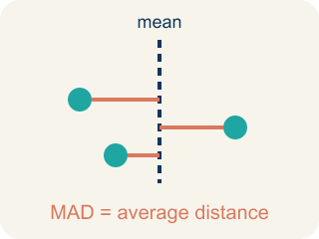
Mean Absolute Deviation (Desviación media absoluta) — The average distance of each number from the mean.
Deviation (Desviación) — How far a number is from the mean.
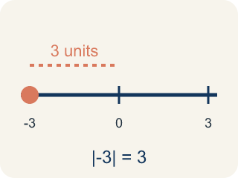
Absolute Value (Valor absoluto) — How far a number is from zero. It is always positive.
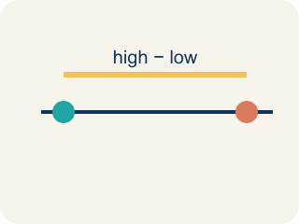
Spread (Dispersión) — How far apart the numbers are.
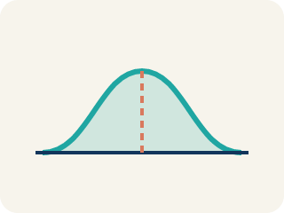
Data distribution (Distribución de datos) — How the data looks: where it sits and how spread out it is.
Variability (Variabilidad) — How spread out the numbers are.

Practice
Show your work. Use the blank space under each problem.
1. The mean of a data set is 15. One value is 11. What is the absolute deviation of that value from the mean?
A. 4
B. −4
C. 26
D. 11
______________________________________________________________________
2. A data set has absolute deviations of 3, 1, 5, 2, 4. What is the MAD?
A. 3
B. 5
C. 15
D. 1
______________________________________________________________________
3. Complete the table.
Score | Deviation (Score − Mean) | Absolute Deviation
12
8
10
14
6
______________________________________________________________________
4. Match each MAD value to what it tells you about the data.
Item | Answer choices
____ MAD = 1.5 | D. Moderate spread
____ MAD = 8.0 | C. All values are identical
____ MAD = 0 | B. Very spread out data
____ MAD = 4.2 | A. Very consistent data
______________________________________________________________________
5. Sort these data sets from LEAST spread out (lowest MAD) to MOST spread out (highest MAD).
Groups: Least to most spread out
______________________________________________________________________
6. Two runners have the same average time of 60 seconds. Runner A's MAD is 1.2 seconds. Runner B's MAD is 5.8 seconds. Which runner is the coach more likely to pick for a relay race that needs a reliable time?
A. Runner A — lower MAD means more consistent times
B. Runner B — higher MAD means faster potential
C. Either — they have the same average
D. Neither — MAD doesn't matter for relay races
______________________________________________________________________
7. onLevel — Spot the Common Mistake
Step 1 (Read): A student is working on Mean Absolute Deviation.
Step 2 (Attempt): They ignored the rule: MAD = the average of how far each number is from the mean (always a positive distance).
Step 3 (Check): The answer does not match the math rule from class.
Which step has the mistake? Explain and fix it:
______________________________________________________________________
______________________________________________________________________
______________________________________________________________________
8. A guard scored 2, 4, 6, 8 points in four scrimmages, so the mean is 5 points. The distances from the mean are 3, 1, 1, 3. What is the mean absolute deviation (MAD)?
A. 1
B. 2
C. 5
D. 8
______________________________________________________________________
9. Two shooters average 11 points a game. Shooter A's MAD is 2 points and Shooter B's MAD is 6 points. Which shooter is MORE consistent?
A. Shooter A, because a smaller MAD means scores stay closer to the average
B. Shooter B, because a bigger MAD means a bigger average
C. They are equally consistent because they have the same mean
D. You cannot tell consistency from MAD
______________________________________________________________________
10. Each player's points are listed. Match each player's data set to its correct MAD. (Hint: find the mean first, then average the distances.)
Item | Answer choices
____ Bench: 8, 10, 12, 14 | C. MAD = 5 points
____ Rookie: 4, 4, 4, 4 | B. MAD = 0 points
____ Starter: 5, 15, 5, 15 | A. MAD = 2 points
______________________________________________________________________

Answer Key (Teacher)
1. A. 4
Deviation = 11 − 15 = −4. Absolute deviation = |−4| = 4.
Watch for: A common mistake in Mean Absolute Deviation is skipping the key idea: "MAD = the average of how far each number is from the mean (always a positive distance)." — always check your work against this rule before you submit.
2. A. 3
Sum of absolute deviations = 3 + 1 + 5 + 2 + 4 = 15. MAD = 15 ÷ 5 = 3.
Watch for: A common mistake in Mean Absolute Deviation is skipping the key idea: "MAD = the average of how far each number is from the mean (always a positive distance)." — always check your work against this rule before you submit.
3. Table
12 — Deviation (Score − Mean): 2
12 — Absolute Deviation: 2
8 — Deviation (Score − Mean): -2
8 — Absolute Deviation: 2
10 — Deviation (Score − Mean): 0
10 — Absolute Deviation: 0
14 — Deviation (Score − Mean): 4
14 — Absolute Deviation: 4
6 — Deviation (Score − Mean): -4
6 — Absolute Deviation: 4

4. Matches:
MAD = 1.5 → Very consistent data
MAD = 8.0 → Very spread out data
MAD = 0 → All values are identical
MAD = 4.2 → Moderate spread

5. Correct groups:

6. A. Runner A — lower MAD means more consistent times
Runner A's MAD of 1.2 means times are usually within 1.2 seconds of 60. Runner B's times vary more widely. For reliability, pick Runner A.
Watch for: A common mistake in Mean Absolute Deviation is skipping the key idea: "MAD = the average of how far each number is from the mean (always a positive distance)." — always check your work against this rule before you submit.
7. onLevel — Spot the Common Mistake
The mistake is in Step 2.
Correct work: Follow the key idea: MAD = the average of how far each number is from the mean (always a positive distance).
8. B. 2
Add the distances: 3 + 1 + 1 + 3 = 8. Divide by the 4 games: 8 ÷ 4 = 2. The MAD is 2 points.
Watch for: A common mistake in Mean Absolute Deviation is skipping the key idea: "MAD = the average of how far each number is from the mean (always a positive distance)." — always check your work against this rule before you submit.
9. A. Shooter A, because a smaller MAD means scores stay closer to the average
A smaller MAD means the scores hug the mean. Shooter A's MAD of 2 is smaller than Shooter B's 6, so Shooter A is more consistent.
Watch for: A common mistake in Mean Absolute Deviation is skipping the key idea: "MAD = the average of how far each number is from the mean (always a positive distance)." — always check your work against this rule before you submit.
10. Matches:
Bench: 8, 10, 12, 14 → MAD = 2 points
Rookie: 4, 4, 4, 4 → MAD = 0 points
Starter: 5, 15, 5, 15 → MAD = 5 points

