UNIT 8 · LESSON 5 STANDARD 6.SP.4

Display Data: Box Plots
Student Notes Packet
Name: ______________________ Date: ____________ Period: ________

Today's Goals
Content: I can make and read a box plot to summarize a data set.
Language: I can explain my box plot using the words box plot, median, quartile, and interquartile range.

Key Vocabulary
Look at the picture, read the word, then read what it means.
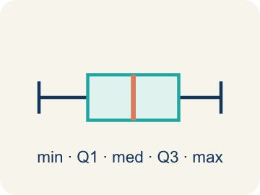 | Box Plot Diagrama de caja  A graph that shows how data is spread using five key numbers.  Example: A box from Q1 to Q3 with a line at the median, and whiskers from min to max
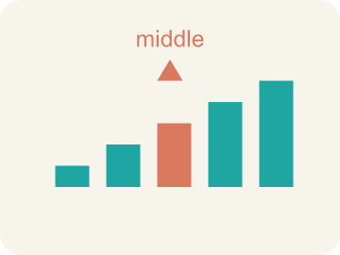 | Median Mediana  The middle number that splits the data in half.  Example: Data: 10, 15, 20, 25, 30 → median is 20 (the 3rd value)
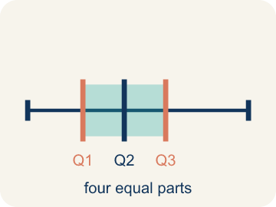 | Quartile Cuartil  Numbers that split the data into four equal parts.  Example: Data: 2, 4, 6, 8, 10, 12, 14 → Q1 = 4 (median of lower half), Q3 = 12 (median of upper half)
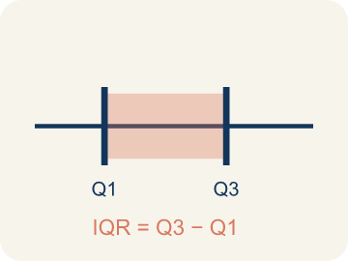 | Interquartile Range Rango intercuartílico  The spread of the middle half of the data (Q3 − Q1).  Example: If Q1 = 12 and Q3 = 20, then IQR = 20 − 12 = 8 — the middle 50% spans 8 units
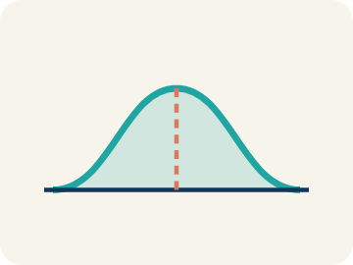 | Data distribution Distribución de datos  How the data looks: where it sits and how spread out it is.  Example: A box plot where the median is centered in the box shows symmetric distribution
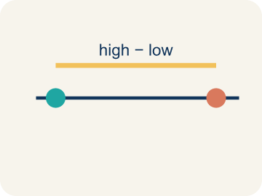 | Variability Variabilidad  How spread out the numbers are.  Example: Small IQR = low variability in the middle 50%. Large IQR = high variability

Guided Notes
Fill in each blank as we go. Use the Word Bank to help you.
WORD BANK
Box Plot • Median • Quartile • Interquartile Range • Data distribution • Variability

1. A graph that shows data with a box and whiskers based on the five-number summary is a ___.
2. The middle value of the data, shown as a line inside the box, is the ___.
3. A value that divides the data into four equal parts is a ___.
4. The distance between the first and third quartiles, showing the middle 50% of data, is the ___.
5. The way data values are spread out is the ___.
6. How spread out the data values are is the ___.

Worked Example

Watch & Read I Do — follow along with your teacher
Team Scoring Breakdown
The basketball league wants to compare scoring across teams. Here are the points scored by each player on the Wildcats in their last game: 4, 6, 8, 10, 12, 14, 15, 18, 22, 24, 28. The league needs a quick visual that shows the spread, the middle 50%, and any high or low scorers. Time to build a box plot!

Think about:
• What are the lowest and highest scores?
• What score is in the middle of the data?
• Are the scores bunched together or spread out?
• How can you show the spread of all this data in one picture?
• What does the 'middle half' of the data look like?

Solved Example I Do — watch each step
Problem: A box plot shows: Min = 10, Q1 = 15, Median = 20, Q3 = 28, Max = 35. What is the interquartile range (IQR)?
A) 13
B) 25
C) 10
D) 20
Step 1: IQR = Q3 − Q1 = 28 − 15 = 13.
Answer: A. 13

Guided Practice

Solve Together We Do — work with your class
Problem: On a box plot, what does the line inside the box represent?
A) The median
B) The mean
C) The mode
D) The range
Step 1:

Step 2:

Answer:

Two basketball teams' scoring data are displayed as box plots. Team A: Min=40, Q1=52, Median=60, Q3=68, Max=75. Team B: Min=35, Q1=55, Median=61, Q3=65, Max=80. A fan says Team B is better because they scored 80 points once.
Which team is more consistently scoring high? Use the box plot values to support your answer.

Sentence frame: Team A's IQR is ___ and Team B's IQR is ___. Team A's middle 50% scores between ___ and ___. The fan is wrong because ___. The box plot shows that ___ is more consistent because ___.

Turn & Talk discuss with a partner
1. [Launch] The Wildcats' scores are 4, 6, 8, 10, 12, 14, 15, 18, 22, 24, 28. To build a box plot you need a five-number summary. What five numbers will you need?
Start with: A box plot needs the ___, Q1, median, Q3, and ___.
Un diagrama de caja necesita el ___, Q1, mediana, Q3 y el ___.
Word bank: box plot, median, quartile, interquartile range, minimum
2. [Explore] As you draw the box from Q1 to Q3, what does the length of the box tell you about the players' scores?
Start with: The box covers the middle ___ of the scores.
La caja cubre el ___ medio de los puntajes.
Word bank: box plot, median, quartile, interquartile range, spread
3. [Connect] Team A: Min=40, Q1=52, Med=60, Q3=68, Max=75. Team B: Min=35, Q1=55, Med=61, Q3=65, Max=80. A fan says Team B is better because they scored 80 once. Which team scores high more consistently?
Start with: Team ___ scores high more consistently because their ___ is higher.
El Equipo ___ anota alto más consistentemente porque su ___ es mayor.
Word bank: box plot, median, quartile, interquartile range, maximum
4. [Reflect] A box plot has Q1 = 20 and Q3 = 36. What is the IQR, and what does it represent?
Start with: The IQR is ___ because Q3 minus Q1 equals ___.
El RIC es ___ porque Q3 menos Q1 es ___.
Word bank: interquartile range, quartile, median, box plot, spread
5. [Practice] During practice on Display Data: Box Plots, what strategy did you use when a problem felt tricky?
Start with: The box covers the middle ___ of the scores.
La caja cubre el ___ medio de los puntajes.
Word bank: Box Plot, Median, Quartile, Interquartile Range

Independent Practice

On Your Own You Do — show your work
Solve each problem. Show your thinking in the work box.
1. What percentage of data falls between Q1 and Q3 on a box plot?
A) 50%
B) 25%
C) 75%
D) 100%

2. Find the range of: 14, 22, 8, 31, 17
A) 23
B) 31
C) 8
D) 18

3. Two box plots show: Team A has IQR = 8, Team B has IQR = 22. What does this tell you?
A) Team A's middle 50% is more consistent; Team B's is more spread out
B) Team B is a better team
C) Team A has a higher median
D) The IQRs don't tell you about consistency

4. The Hawks' points per quarter are 2, 4, 5, 7, 8, 10, 12. Resting on the scoreboard, what are the minimum, median, and maximum?
A) Minimum 2, median 7, maximum 12
B) Minimum 2, median 5, maximum 12
C) Minimum 0, median 7, maximum 12
D) Minimum 2, median 8, maximum 10

Exit Ticket
Answer on your own. This shows what you learned today.
★ A box plot has Q1 = 20 and Q3 = 36. What is the IQR and what does it represent?
A) IQR = 16; it is the spread of the middle 50% of the data
B) IQR = 56; it is the total of Q1 and Q3
C) IQR = 28; it is the median between Q1 and Q3
D) IQR = 36; it is the value of Q3

