Display Data: Box Plots — Homework
Lesson 8-5 • Standard 6.DS.5
Name: ______________________ Period: ______ Date: ____________

Today's Goals
Content: I can make and read a box plot to summarize a data set.
Language: I can explain my box plot using the words box plot, median, quartile, and interquartile range.

Key Words
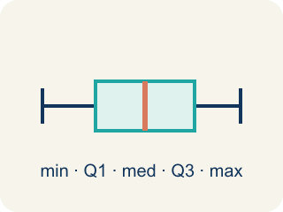
Box Plot (Diagrama de caja) — A graph that shows how data is spread using five key numbers.
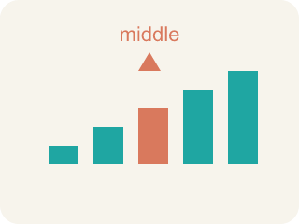
Median (Mediana) — The middle number that splits the data in half.
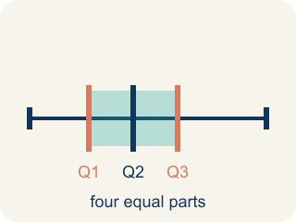
Quartile (Cuartil) — Numbers that split the data into four equal parts.
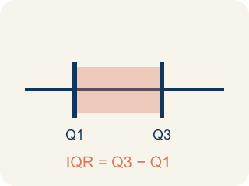
Interquartile Range (Rango intercuartílico) — The spread of the middle half of the data (Q3 − Q1).
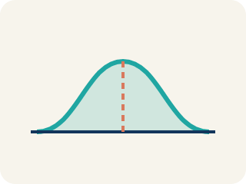
Data distribution (Distribución de datos) — How the data looks: where it sits and how spread out it is.
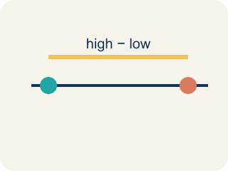
Variability (Variabilidad) — How spread out the numbers are.

Practice
Show your work. Use the blank space under each problem.
1. A box plot shows: Min = 10, Q1 = 15, Median = 20, Q3 = 28, Max = 35. What is the interquartile range (IQR)?
A. 13
B. 25
C. 10
D. 20
______________________________________________________________________
2. On a box plot, what does the line inside the box represent?
A. The median
B. The mean
C. The mode
D. The range
______________________________________________________________________
3. Complete the table.
Measure | Value
Data: 5, 8, 12, 15, 18, 20, 25, 30, 35
Minimum
Q1 (median of lower half: 5, 8, 12, 15)
Median
Q3 (median of upper half: 20, 25, 30, 35)
Maximum
IQR (Q3 − Q1)
______________________________________________________________________
4. Match each box plot term to its meaning.
Item | Answer choices
____ Minimum | F. Largest value in the data set
____ Q1 | E. Q3 − Q1 (spread of middle 50%)
____ Median | D. Median of the upper half
____ Q3 | C. Middle value of the entire data set
____ IQR | B. Median of the lower half
____ Maximum | A. Smallest value in the data set
______________________________________________________________________
5. Two box plots show: Team A has IQR = 8, Team B has IQR = 22. What does this tell you?
A. Team A's middle 50% is more consistent; Team B's is more spread out
B. Team B is a better team
C. Team A has a higher median
D. The IQRs don't tell you about consistency
______________________________________________________________________
6. onLevel — Spot the Common Mistake
Step 1 (Read): A student is working on Display Data: Box Plots.
Step 2 (Attempt): They ignored the rule: The box always holds the middle 50% of the data, and the line inside the box is the median.
Step 3 (Check): The answer does not match the math rule from class.
Which step has the mistake? Explain and fix it:
______________________________________________________________________
______________________________________________________________________
______________________________________________________________________
7. The Hawks' points per quarter are 2, 4, 5, 7, 8, 10, 12. Resting on the scoreboard, what are the minimum, median, and maximum?
A. Minimum 2, median 7, maximum 12
B. Minimum 2, median 5, maximum 12
C. Minimum 0, median 7, maximum 12
D. Minimum 2, median 8, maximum 10
______________________________________________________________________
8. The Comets scored 6, 10, 14, 18, 22, 26, 30, 34 across 8 games. After ordering, what are Q1 and Q3?
A. Q1 = 12, Q3 = 28
B. Q1 = 10, Q3 = 30
C. Q1 = 14, Q3 = 26
D. Q1 = 20, Q3 = 34
______________________________________________________________________
9. Match each team's ordered scores to its five-number summary (min, Q1, median, Q3, max).
Item | Answer choices
____ Hawks: 5, 8, 11, 15, 18, 21, 27 | D. Min 4, Q1 7, Median 16, Q3 25, Max 31
____ Comets: 10, 13, 16, 20, 24, 28, 33 | C. Min 2, Q1 6, Median 14, Q3 23, Max 30
____ Jets: 2, 6, 9, 14, 19, 23, 30 | B. Min 10, Q1 13, Median 20, Q3 28, Max 33
____ Suns: 4, 7, 10, 16, 22, 25, 31 | A. Min 5, Q1 8, Median 15, Q3 21, Max 27
______________________________________________________________________
10. Each card describes a part of the stadium box plot. Sort each card under the matching box plot part.
Groups: Part of the five-number summary | Measure of spread
• The minimum — the lowest score → __________________
• Q1 — the median of the lower half → __________________
• The median — the middle score → __________________
• Q3 — the median of the upper half → __________________
• The maximum — the highest score → __________________
• IQR — Q3 minus Q1 → __________________
• Range — maximum minus minimum → __________________
______________________________________________________________________

Answer Key (Teacher)
1. A. 13
IQR = Q3 − Q1 = 28 − 15 = 13.
Watch for: A common mistake in Display Data: Box Plots is skipping the key idea: "The box always holds the middle 50% of the data, and the line inside the box is the median." — always check your work against this rule before you submit.
2. A. The median
The line inside the box of a box plot always represents the median.
Watch for: A common mistake in Display Data: Box Plots is skipping the key idea: "The box always holds the middle 50% of the data, and the line inside the box is the median." — always check your work against this rule before you submit.
3. Table
Minimum — Value: 5
Q1 (median of lower half: 5, 8, 12, 15) — Value: 10
Median — Value: 18
Q3 (median of upper half: 20, 25, 30, 35) — Value: 27.5
Maximum — Value: 35
IQR (Q3 − Q1) — Value: 17.5

4. Matches:
Minimum → Smallest value in the data set
Q1 → Median of the lower half
Median → Middle value of the entire data set
Q3 → Median of the upper half
IQR → Q3 − Q1 (spread of middle 50%)
Maximum → Largest value in the data set

5. A. Team A's middle 50% is more consistent; Team B's is more spread out
A smaller IQR means the middle 50% of data is more tightly clustered. Team A's scoring is more consistent in the middle range.
Watch for: A common mistake in Display Data: Box Plots is skipping the key idea: "The box always holds the middle 50% of the data, and the line inside the box is the median." — always check your work against this rule before you submit.
6. onLevel — Spot the Common Mistake
The mistake is in Step 2.
Correct work: Follow the key idea: The box always holds the middle 50% of the data, and the line inside the box is the median.
7. A. Minimum 2, median 7, maximum 12
The data is already in order. The smallest value is 2 and the largest is 12. There are 7 values, so the median is the 4th value, which is 7.
Watch for: A common mistake in Display Data: Box Plots is skipping the key idea: "The box always holds the middle 50% of the data, and the line inside the box is the median." — always check your work against this rule before you submit.
8. A. Q1 = 12, Q3 = 28
With 8 values the median splits the data into a lower half (6, 10, 14, 18) and an upper half (22, 26, 30, 34). Q1 is the median of the lower half: (10 + 14) ÷ 2 = 12. Q3 is the median of the upper half: (26 + 30) ÷ 2 = 28.
Watch for: A common mistake in Display Data: Box Plots is skipping the key idea: "The box always holds the middle 50% of the data, and the line inside the box is the median." — always check your work against this rule before you submit.
9. Matches:
Hawks: 5, 8, 11, 15, 18, 21, 27 → Min 5, Q1 8, Median 15, Q3 21, Max 27
Comets: 10, 13, 16, 20, 24, 28, 33 → Min 10, Q1 13, Median 20, Q3 28, Max 33
Jets: 2, 6, 9, 14, 19, 23, 30 → Min 2, Q1 6, Median 14, Q3 23, Max 30
Suns: 4, 7, 10, 16, 22, 25, 31 → Min 4, Q1 7, Median 16, Q3 25, Max 31

10. Correct groups:
The minimum — the lowest score → Part of the five-number summary
Q1 — the median of the lower half → Part of the five-number summary
The median — the middle score → Part of the five-number summary
Q3 — the median of the upper half → Part of the five-number summary
The maximum — the highest score → Part of the five-number summary
IQR — Q3 minus Q1 → Measure of spread
Range — maximum minus minimum → Measure of spread

