UNIT 8 · LESSON 6 STANDARD 6.SP.4

Display Data: Histograms
Student Notes Packet
Name: ______________________ Date: ____________ Period: ________

Today's Goals
Content: I can make and read a histogram to display data in intervals.
Language: I can explain my histogram using the words histogram, frequency, interval, and distribution.

Key Vocabulary
Look at the picture, read the word, then read what it means.
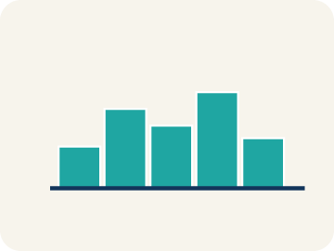 | Histogram Histograma  A bar graph that groups data into equal ranges. The bars touch.  Example: Bars side by side: 0-9 pts (3 players), 10-19 pts (8 players), 20-29 pts (4 players)
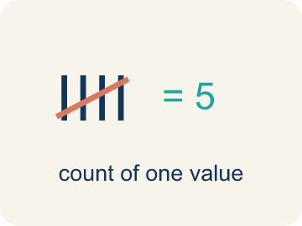 | Frequency Frecuencia  How many times a value shows up.  Example: If 5 players scored 10-19 points, the frequency for that interval is 5
Interval Intervalo
A range of numbers used to group data.
Example: 0-9, 10-19, 20-29 are intervals of width 10 — each covers 10 values
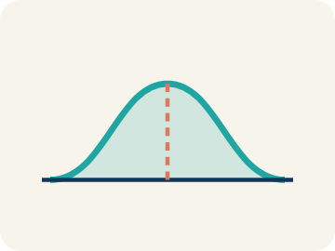 | Distribution Distribución  How the data is spread out.  Example: Most data in the middle with fewer at the ends = bell-shaped; most on one side with a tail = skewed
Data distribution Distribución de datos
How the data looks: where it sits and how spread out it is.
Example: A histogram that is tallest in the middle and shorter on both sides is symmetric
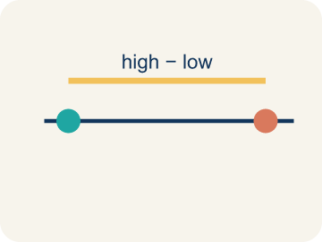 | Variability Variabilidad  How spread out the numbers are.  Example: Data in just 2 intervals = low variability. Data across 6 intervals = high variability

Guided Notes
Fill in each blank as we go. Use the Word Bank to help you.
WORD BANK
Histogram • Frequency • Interval • Distribution • Data distribution • Variability

1. A bar graph that shows how often data falls into equal intervals is a ___.
2. How many data values fall in an interval is the ___.
3. An equal-sized range of values used to group data is an ___.
4. The overall pattern of how data is spread out is the ___.
5. The way data values are spread out is the ___.
6. How much the data values differ is the ___.

Worked Example

Watch & Read I Do — follow along with your teacher
League Stats Organizer
The basketball league has 30 players and wants to display everyone's points-per-game average in a way that shows how the data is distributed. The raw averages are: 2, 5, 7, 8, 9, 10, 11, 11, 12, 13, 13, 14, 14, 15, 15, 16, 16, 17, 18, 18, 19, 20, 21, 22, 23, 24, 25, 28, 30, 32. Listing all 30 numbers is hard to read — a histogram will reveal the pattern!

Think about:
• Where do most of the scoring averages seem to cluster?
• Are there many players at the very low or very high end?
• How could you group these numbers to see a pattern?
• What size intervals would work best for this data?
• What shape will the data make when grouped into a histogram?

Solved Example I Do — watch each step
Problem: A histogram shows these frequencies: 0–4: 3 players, 5–9: 8 players, 10–14: 12 players, 15–19: 5 players. How many players are represented in total?
A) 28
B) 12
C) 20
D) 15
Step 1: Add all frequencies: 3 + 8 + 12 + 5 = 28 players.
Answer: A. 28

Guided Practice

Solve Together We Do — work with your class
Problem: In a histogram, what does the height of each bar represent?
A) The frequency (count) of data in that interval
B) The average of the data in that interval
C) The range of the interval
D) The median of the data
Step 1:

Step 2:

Answer:

A soccer coach looks at a histogram of shots-per-game for the team: 0–2 shots: 1 player, 3–5 shots: 8 players, 6–8 shots: 10 players, 9–11 shots: 3 players, 12–14 shots: 1 player. The coach says, 'Most of my players take a good number of shots.'
Does the histogram support the coach's claim? What does the shape of the data tell you?

Sentence frame: The histogram peaks at the ___ interval with ___ players. The shape is approximately ___. This ___ the coach's claim because ___.

Turn & Talk discuss with a partner
1. [Launch] You have 30 players' points-per-game averages. Why is it easier to display them in a histogram with intervals than to list all 30 numbers?
Start with: A histogram is easier because it groups the data into ___.
Un histograma es más fácil porque agrupa los datos en ___.
Word bank: histogram, frequency, interval, distribution, bar
2. [Explore] As you build the frequency table with intervals of 10, what does the height of each bar in the histogram represent?
Start with: The height of each bar shows the ___ of that interval.
La altura de cada barra muestra la ___ de ese intervalo.
Word bank: histogram, frequency, interval, distribution, bar
3. [Connect] A histogram of shots-per-game shows 0-2: 1 player, 3-5: 8, 6-8: 10, 9-11: 3, 12-14: 1. The coach says 'most players take a good number of shots.' Does the shape support that claim?
Start with: The histogram ___ the coach's claim because most players are in the ___ intervals.
El histograma ___ la afirmación porque la mayoría está en los intervalos ___.
Word bank: histogram, frequency, interval, distribution, shape
4. [Reflect] A histogram of heights shows 60-63 in: 2, 64-67 in: 7, 68-71 in: 9, 72-75 in: 4. Which interval has the most players, and how do you know?
Start with: The ___ interval has the most players because its bar is ___.
El intervalo ___ tiene más jugadores porque su barra es ___.
Word bank: histogram, frequency, interval, distribution, bar
5. [Practice] During practice on Display Data: Histograms, what strategy did you use when a problem felt tricky?
Start with: The height of each bar shows the ___ of that interval.
La altura de cada barra muestra la ___ de ese intervalo.
Word bank: Histogram, Frequency, Interval, Distribution

Independent Practice

On Your Own You Do — show your work
Solve each problem. Show your thinking in the work box.
1. How is a histogram different from a regular bar graph?
A) Histogram bars touch (no gaps) because the intervals are continuous ranges
B) Histograms use colors and bar graphs don't
C) Bar graphs show numbers and histograms show words
D) There is no difference

2. A histogram has intervals: 0–4, 5–9, 10–14, 15–19. What is the width of each interval?
A) 5
B) 4
C) 10
D) 19

3. A histogram bar for the interval 20–29 reaches a height of 7. What does the 7 tell you?
A) 7 data values fall between 20 and 29
B) The largest value is 7
C) There are 7 intervals
D) The interval is 7 wide

4. A histogram of test scores shows: 50–59: 2, 60–69: 5, 70–79: 10, 80–89: 8, 90–99: 3. Which interval has the most students?
A) 70–79 with 10 students
B) 80–89 with 8 students
C) 60–69 with 5 students
D) 90–99 with 3 students

Exit Ticket
Answer on your own. This shows what you learned today.
★ A histogram of player heights shows: 60–63 in: 2, 64–67 in: 7, 68–71 in: 9, 72–75 in: 4. Which interval has the most players?
A) 68–71 inches
B) 64–67 inches
C) 72–75 inches
D) 60–63 inches

