Display Data: Histograms — Homework
Lesson 8-6 • Standard 6.DS.5
Name: ______________________ Period: ______ Date: ____________

Today's Goals
Content: I can make and read a histogram to display data in intervals.
Language: I can explain my histogram using the words histogram, frequency, interval, and distribution.

Key Words
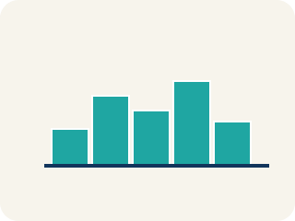
Histogram (Histograma) — A bar graph that groups data into equal ranges. The bars touch.
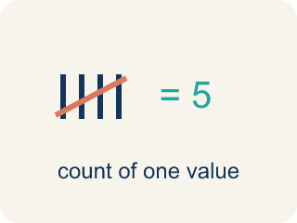
Frequency (Frecuencia) — How many times a value shows up.
Interval (Intervalo) — A range of numbers used to group data.
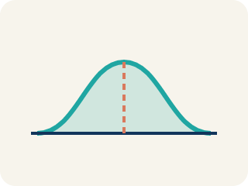
Distribution (Distribución) — How the data is spread out.
Data distribution (Distribución de datos) — How the data looks: where it sits and how spread out it is.
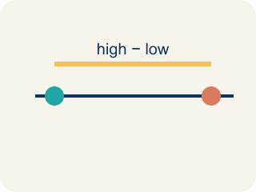
Variability (Variabilidad) — How spread out the numbers are.

Practice
Show your work. Use the blank space under each problem.
1. A histogram shows these frequencies: 0–4: 3 players, 5–9: 8 players, 10–14: 12 players, 15–19: 5 players. How many players are represented in total?
A. 28
B. 12
C. 20
D. 15
______________________________________________________________________
2. In a histogram, what does the height of each bar represent?
A. The frequency (count) of data in that interval
B. The average of the data in that interval
C. The range of the interval
D. The median of the data
______________________________________________________________________
3. Complete the table.
Interval (Yards) | Frequency
Player rushing yards per game: 0, 5, 12, 15, 18, 22, 25, 28, 31, 35, 40, 45
0–9
10–19
20–29
30–39
40–49
______________________________________________________________________
4. A histogram of test scores shows: 50–59: 2, 60–69: 5, 70–79: 10, 80–89: 8, 90–99: 3. Which interval has the most students?
A. 70–79 with 10 students
B. 80–89 with 8 students
C. 60–69 with 5 students
D. 90–99 with 3 students
______________________________________________________________________
5. Match each term to its description.
Item | Answer choices
____ Histogram | D. Range of values grouped together
____ Bar graph | C. Count of values in an interval
____ Frequency | B. Bars separated, shows categories
____ Interval | A. Bars touch, shows frequency by interval
______________________________________________________________________
6. Based on the histogram frequencies below, sort the intervals from most players to fewest: 0–9: 4, 10–19: 11, 20–29: 7, 30–39: 2.
Groups: Most to fewest players
______________________________________________________________________
7. A histogram of goals-per-game shows: 0–1: 9 players, 2–3: 6, 4–5: 3, 6–7: 1. What shape is this distribution?
A. Skewed right (most players low, tail toward high values)
B. Skewed left (most players high, tail toward low values)
C. Perfectly symmetric
D. Flat / uniform (all bars equal)
______________________________________________________________________
8. Use this data set of rebounds per game to complete the frequency table (intervals of 5): 1, 3, 4, 6, 7, 8, 9, 11, 12, 13, 14, 16.
Interval (Rebounds) | Frequency
0–4
5–9
10–14
15–19
______________________________________________________________________
9. onLevel — Spot the Common Mistake
Step 1 (Read): A student is working on Display Data: Histograms.
Step 2 (Attempt): They ignored the rule: Each bar's height shows how many data values land inside that interval.
Step 3 (Check): The answer does not match the math rule from class.
Which step has the mistake? Explain and fix it:
______________________________________________________________________
______________________________________________________________________
______________________________________________________________________
10. Coach recorded these minutes played by 14 players: 4, 8, 9, 12, 14, 15, 17, 18, 19, 22, 24, 27, 31, 33. Using intervals of 10, how many values fall in the 10–19 interval?
A. 6
B. 3
C. 9
D. 5
______________________________________________________________________

Answer Key (Teacher)
1. A. 28
Add all frequencies: 3 + 8 + 12 + 5 = 28 players.
Watch for: A common mistake in Display Data: Histograms is skipping the key idea: "Each bar's height shows how many data values land inside that interval." — always check your work against this rule before you submit.
2. A. The frequency (count) of data in that interval
Each bar's height shows the frequency — how many data values fall within that interval.
Watch for: A common mistake in Display Data: Histograms is skipping the key idea: "Each bar's height shows how many data values land inside that interval." — always check your work against this rule before you submit.
3. Table
0–9 — Frequency: 2
10–19 — Frequency: 3
20–29 — Frequency: 3
30–39 — Frequency: 2
40–49 — Frequency: 2

4. A. 70–79 with 10 students
The 70–79 interval has the highest frequency of 10 students.
Watch for: A common mistake in Display Data: Histograms is skipping the key idea: "Each bar's height shows how many data values land inside that interval." — always check your work against this rule before you submit.
5. Matches:
Histogram → Bars touch, shows frequency by interval
Bar graph → Bars separated, shows categories
Frequency → Count of values in an interval
Interval → Range of values grouped together

6. Correct groups:

7. A. Skewed right (most players low, tail toward high values)
The tallest bars are at the low end (0–1) and the bars shrink as goals increase — the tail points right, so it is skewed right.
Watch for: A common mistake in Display Data: Histograms is skipping the key idea: "Each bar's height shows how many data values land inside that interval." — always check your work against this rule before you submit.
8. Use this data set of rebounds per game to complete the frequency table (intervals of 5): 1, 3, 4, 6, 7, 8, 9, 11, 12, 13, 14, 16.
0–4 — Frequency: 3
5–9 — Frequency: 4
10–14 — Frequency: 4
15–19 — Frequency: 1

9. onLevel — Spot the Common Mistake
The mistake is in Step 2.
Correct work: Follow the key idea: Each bar's height shows how many data values land inside that interval.
10. A. 6
The values 12, 14, 15, 17, 18, and 19 all fall between 10 and 19, so the frequency for that bin is 6.
Watch for: A common mistake in Display Data: Histograms is skipping the key idea: "Each bar's height shows how many data values land inside that interval." — always check your work against this rule before you submit.

