UNIT 8 · LESSON 7 STANDARD 6.SP.2

Shape of Data Distributions
Student Notes Packet
Name: ______________________ Date: ____________ Period: ________

Today's Goals
Content: I can describe the shape of a data distribution as symmetric, skewed, or having clusters and gaps.
Language: I can explain my description using the words symmetric, skewed, cluster, and gap.

Key Vocabulary
Look at the picture, read the word, then read what it means.
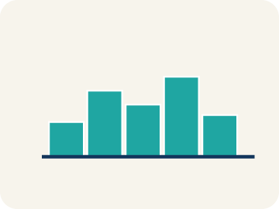 | Symmetric Simétrico  Data that looks about the same on the left and right.  Example: Heights: 60, 62, 64, 66, 68, 66, 64, 62, 60 — rises and falls evenly like a hill
Skewed Sesgado
Data bunched on one side with a tail on the other.
Example: Skewed right: most data low (1,2,2,3,3,3,15) — tail stretches toward the high value
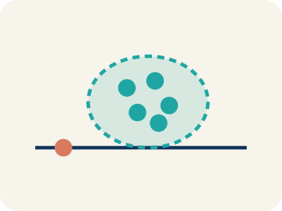 | Cluster Agrupamiento  A group of numbers that are close together.  Example: Scores 18, 19, 20, 21, 22 form a cluster around 20 — they are tightly grouped
Gap Hueco (espacio)
A big empty space where there is no data.
Example: Data: 5, 6, 7, 8, ___, ___, ___, 20 — the empty space from 9 to 19 is a gap
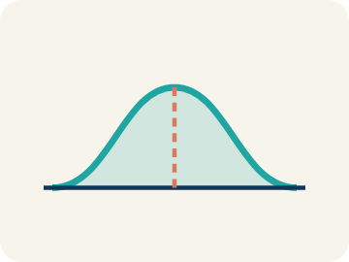 | Data distribution Distribución de datos  How the data looks: where it sits and how spread out it is.  Example: Looking at a dot plot or histogram, you can see if data is symmetric, skewed, clustered, or has gaps
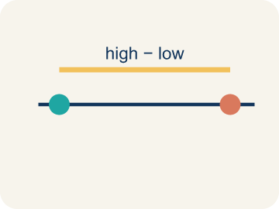 | Variability Variabilidad  How spread out the numbers are.  Example: Symmetric data with low variability: tightly packed around the center. Skewed data: spread unevenly

Guided Notes
Fill in each blank as we go. Use the Word Bank to help you.
WORD BANK
Symmetric • Skewed • Cluster • Gap • Data distribution • Variability

1. A distribution where both sides look like mirror images is ___.
2. A distribution with a tail stretching out to one side is ___.
3. A group of data values bunched close together is a ___.
4. An interval where there are no data values is a ___.
5. The way data values are spread out across a range is the ___.
6. How much the values in a data set differ from one another is the ___.

Worked Example

Watch & Read I Do — follow along with your teacher
Distribution Detective
The league analyst is studying three different data sets from the season: (1) Player heights across all teams, (2) Number of 3-pointers per game by each player, and (3) Years of experience for all coaches. Each data set has a different shape when graphed. Your job is to describe each shape and explain what it tells us about the data.

Think about:
• Do the three data sets look the same when graphed?
• Which graph has data bunched in the middle? Which has a long tail?
• Are there any gaps or clusters you can spot?
• Why would different sports data have different shapes?
• Does the shape tell you which measure of center to use?

Solved Example I Do — watch each step
Problem: A histogram of basketball players' ages shows: most players are 22–28, with a long tail of older players up to age 40. What is the shape of this distribution?
A) Skewed right
B) Symmetric
C) Skewed left
D) Uniform
Step 1: Most data is on the left (younger ages) with a tail stretching right (older ages).
Step 2: This is skewed right.
Answer: A. Skewed right

Guided Practice

Solve Together We Do — work with your class
Problem: A data set is symmetric. What is likely true about the mean and median?
A) They are approximately equal
B) The mean is much higher than the median
C) The median is much higher than the mean
D) They are always exactly the same
Step 1:

Step 2:

Answer:

A sports reporter is writing about marathon finish times. The data shows: most runners finish between 3.5–4.5 hours, with a small group of elite runners finishing in 2.0–2.5 hours, and a long tail of slower runners finishing in 5–7 hours.
What is the shape of this distribution? Should the reporter use the mean or median to describe a 'typical' finish time?

Sentence frame: The distribution is skewed ___ because the tail stretches toward the ___ finish times. There is a cluster around ___. The reporter should use the ___ because the ___ would be pulled toward the ___ by the extreme values.

Turn & Talk discuss with a partner
1. [Launch] The analyst graphs player heights, 3-pointers per game, and coaches' years of experience. Why might each data set have a DIFFERENT shape when graphed?
Start with: The shapes are different because the data ___.
Las formas son diferentes porque los datos ___.
Word bank: symmetric, skewed, cluster, gap, distribution
2. [Explore] As you match each data description to its shape, how can you tell a symmetric distribution from a skewed one just by looking?
Start with: A symmetric distribution has data that is ___ on both sides.
Una distribución simétrica tiene datos ___ en ambos lados.
Word bank: symmetric, skewed, cluster, gap, tail
3. [Connect] Marathon times cluster at 3.5-4.5 hours, with elites at 2.0-2.5 and a long tail of slower runners at 5-7 hours. What is the shape, and should the reporter use the mean or median for a 'typical' time?
Start with: This distribution is skewed to the ___ because of the long tail of ___.
Esta distribución está sesgada hacia la ___ por la cola larga de ___.
Word bank: symmetric, skewed, cluster, gap, distribution
4. [Reflect] A data set has most values clustered between 40-60 with a few at 90-100. What is the shape of the distribution, and which measure of center is best?
Start with: The shape is skewed to the ___ because of the values at ___.
La forma está sesgada hacia la ___ por los valores en ___.
Word bank: symmetric, skewed, cluster, gap, median
5. [Practice] During practice on Shape of Data Distributions, what strategy did you use when a problem felt tricky?
Start with: A symmetric distribution has data that is ___ on both sides.
Una distribución simétrica tiene datos ___ en ambos lados.
Word bank: Symmetric, Skewed, Cluster, Gap

Independent Practice

On Your Own You Do — show your work
Solve each problem. Show your thinking in the work box.
1. Match each description with the correct distribution shape.
2. Which word describes the direction of the TAIL, not the peak?
A) Skew — the direction of the long tail tells you the skew direction
B) Skew — the direction of the peak tells you the skew direction
C) Skew — the direction the median points
D) Skew — the direction of the mode

3. A dot plot of goals scored per game shows: 0(5 dots), 1(7 dots), 2(4 dots), 3(2 dots), 4(1 dot). What is the shape?
A) Skewed right — most values at the low end with a tail to the right
B) Symmetric — equal on both sides
C) Skewed left — most values at the high end
D) Uniform — all bars the same height

4. Match the data shape with the best measure of center.

Exit Ticket
Answer on your own. This shows what you learned today.
★ A data set has most values clustered between 40–60, with a few values at 90–100. What is the shape of the distribution and which measure of center is best?
A) Skewed right; use median
B) Symmetric; use mean
C) Skewed left; use median
D) Uniform; use mean

