Shape of Data Distributions — Homework
Lesson 8-7 • Standard 6.DS.3
Name: ______________________ Period: ______ Date: ____________

Today's Goals
Content: I can describe the shape of a data distribution as symmetric, skewed, or having clusters and gaps.
Language: I can explain my description using the words symmetric, skewed, cluster, and gap.

Key Words
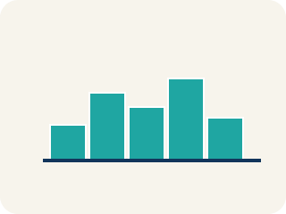
Symmetric (Simétrico) — Data that looks about the same on the left and right.
Skewed (Sesgado) — Data bunched on one side with a tail on the other.
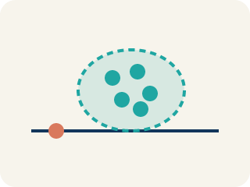
Cluster (Agrupamiento) — A group of numbers that are close together.
Gap (Hueco (espacio)) — A big empty space where there is no data.
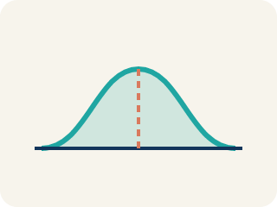
Data distribution (Distribución de datos) — How the data looks: where it sits and how spread out it is.
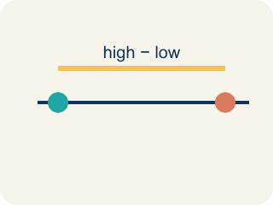
Variability (Variabilidad) — How spread out the numbers are.

Practice
Show your work. Use the blank space under each problem.
1. A histogram of basketball players' ages shows: most players are 22–28, with a long tail of older players up to age 40. What is the shape of this distribution?
A. Skewed right
B. Symmetric
C. Skewed left
D. Uniform
______________________________________________________________________
2. A data set is symmetric. What is likely true about the mean and median?
A. They are approximately equal
B. The mean is much higher than the median
C. The median is much higher than the mean
D. They are always exactly the same
______________________________________________________________________
3. A dot plot of goals scored per game shows: 0(5 dots), 1(7 dots), 2(4 dots), 3(2 dots), 4(1 dot). What is the shape?
A. Skewed right — most values at the low end with a tail to the right
B. Symmetric — equal on both sides
C. Skewed left — most values at the high end
D. Uniform — all bars the same height
______________________________________________________________________
4. Match each distribution shape to how its mean and median compare.
Item | Answer choices
____ Symmetric | C. Mean < Median — use the median (low tail pulls the mean down)
____ Skewed Right | B. Mean > Median — use the median (high tail pulls the mean up)
____ Skewed Left | A. Mean ≈ Median — use either (mean is fine)
______________________________________________________________________
5. For each data set, decide: is it symmetric, skewed right, or skewed left?
Groups: Symmetric | Skewed Right | Skewed Left
______________________________________________________________________
6. onLevel — Spot the Common Mistake
Step 1 (Read): A student is working on Shape of Data Distributions.
Step 2 (Attempt): They ignored the rule: Symmetric data mirrors around the center; skewed data has a long tail, and the skew is named for the direction the tail points.
Step 3 (Check): The answer does not match the math rule from class.
Which step has the mistake? Explain and fix it:
______________________________________________________________________
______________________________________________________________________
______________________________________________________________________
7. Display 1: A histogram of points-per-game has a few short bars stretching out to the high-scoring side, with a long tail of high values on the right. What shape is this distribution?
A. Skewed right
B. Skewed left
C. Symmetric
D. Uniform
______________________________________________________________________
8. Display 2: A dot plot of starting players' heights has one clear peak in the middle, with roughly even sides falling away from that peak. What shape best describes this distribution?
A. Symmetric with one cluster around the peak
B. Skewed right
C. Skewed left
D. Has a large gap
______________________________________________________________________
9. Sort each described sports display into the shape feature it shows best.
Groups: Symmetric | Skewed Right | Skewed Left | Has a Gap | Has a Cluster
• Goals per game: one peak at 1 goal, an even rise and fall on both sides → __________________
• Coach experience (years): most coaches at 1-5 years, a long tail out to 30+ years → __________________
• Veteran kickers' field-goal %: most near 90%, a long tail down to a few near 40% → __________________
• Race times: a group at 12s, nothing from 13-19s, then a group at 20s → __________________
• Jersey numbers: most players bunched tightly between 20 and 29 → __________________
______________________________________________________________________
10. Display 4: Match each feature you spot in a data display to the term that names it.
Item | Answer choices
____ The tallest point of the display where data piles up | D. Tail
____ An empty interval with no data values between two groups | C. Cluster
____ A group of values bunched close together | B. Gap
____ A long stretch of low bars trailing off to one side | A. Peak
______________________________________________________________________

Answer Key (Teacher)
1. A. Skewed right
Most data is on the left (younger ages) with a tail stretching right (older ages). This is skewed right.
Watch for: A common mistake in Shape of Data Distributions is skipping the key idea: "Symmetric data mirrors around the center; skewed data has a long tail, and the skew is named for the direction the tail points." — always check your work against this rule before you submit.
2. A. They are approximately equal
In a symmetric distribution, the mean and median are approximately equal because the data is balanced on both sides.
Watch for: A common mistake in Shape of Data Distributions is skipping the key idea: "Symmetric data mirrors around the center; skewed data has a long tail, and the skew is named for the direction the tail points." — always check your work against this rule before you submit.
3. A. Skewed right — most values at the low end with a tail to the right
The data peaks at 0–1 goals and tails off toward 4. Most data is on the left with fewer values stretching right — this is skewed right.
Watch for: A common mistake in Shape of Data Distributions is skipping the key idea: "Symmetric data mirrors around the center; skewed data has a long tail, and the skew is named for the direction the tail points." — always check your work against this rule before you submit.
4. Matches:
Symmetric → Mean ≈ Median — use either (mean is fine)
Skewed Right → Mean > Median — use the median (high tail pulls the mean up)
Skewed Left → Mean < Median — use the median (low tail pulls the mean down)

5. Correct groups:

6. onLevel — Spot the Common Mistake
The mistake is in Step 2.
Correct work: Follow the key idea: Symmetric data mirrors around the center; skewed data has a long tail, and the skew is named for the direction the tail points.
7. A. Skewed right
A tail of high values stretching to the right means the distribution is skewed right. The skew is named for the tail's direction.
Watch for: A common mistake in Shape of Data Distributions is skipping the key idea: "Symmetric data mirrors around the center; skewed data has a long tail, and the skew is named for the direction the tail points." — always check your work against this rule before you submit.
8. A. Symmetric with one cluster around the peak
One peak in the middle with roughly even sides means the data mirrors around the center, so it is symmetric with a single cluster at the peak.
Watch for: A common mistake in Shape of Data Distributions is skipping the key idea: "Symmetric data mirrors around the center; skewed data has a long tail, and the skew is named for the direction the tail points." — always check your work against this rule before you submit.
9. Correct groups:
Goals per game: one peak at 1 goal, an even rise and fall on both sides → Symmetric
Coach experience (years): most coaches at 1-5 years, a long tail out to 30+ years → Skewed Right
Veteran kickers' field-goal %: most near 90%, a long tail down to a few near 40% → Skewed Left
Race times: a group at 12s, nothing from 13-19s, then a group at 20s → Has a Gap
Jersey numbers: most players bunched tightly between 20 and 29 → Has a Cluster

10. Matches:
The tallest point of the display where data piles up → Peak
An empty interval with no data values between two groups → Gap
A group of values bunched close together → Cluster
A long stretch of low bars trailing off to one side → Tail

