Graph on the Coordinate Plane — Homework
Lesson 9-1 • Standard 6.NOS.6
Name: ______________________ Period: ______ Date: ____________

Today's Goals
Content: I can plot and identify points on the coordinate plane using ordered pairs.
Language: I can explain my work using the words coordinate plane, ordered pair, origin, and quadrant.

Key Words
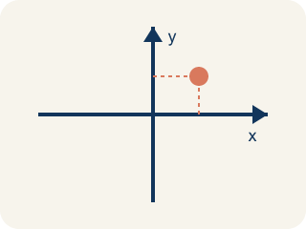
Coordinate plane (Plano cartesiano) — A grid with a line going across and a line going up that cross.
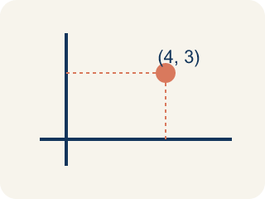
Ordered pair (Par ordenado) — Two numbers (x, y) that tell where a point is on a grid.
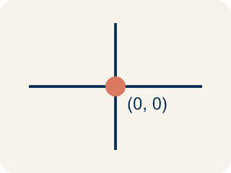
Origin (Origen) — The point (0, 0) where the two grid lines cross.
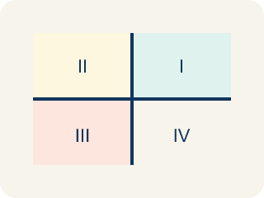
Quadrant (Cuadrante) — One of the four parts of a coordinate grid.
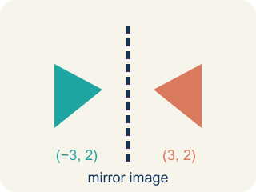
Reflection (Reflexión) — A flipped, mirror image across a line.
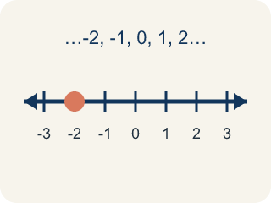
Integer (Número entero) — Whole numbers and their opposites, like -2, -1, 0, 1, 2.

Practice
Show your work. Use the blank space under each problem.
1. Which ordered pair names a point 3 units right and 7 units up from the origin?
A. (3, 7)
B. (7, 3)
C. (3, 3)
D. (0, 7)
______________________________________________________________________
2. What are the coordinates of the origin?
A. (0, 0)
B. (1, 1)
C. (0, 1)
D. (1, 0)
______________________________________________________________________
3. Match each point to its quadrant or axis.
Item | Answer choices
____ (3, 2) | F. x-axis
____ (-4, 5) | E. y-axis
____ (-2, -6) | D. Quadrant IV
____ (7, -1) | C. Quadrant III
____ (0, 3) | B. Quadrant II
____ (5, 0) | A. Quadrant I
______________________________________________________________________
4. Complete the table. Write the ordered pair for each description.
Description | Ordered Pair
Right 7, Up 2
Right 0, Up 5
Right 4, Up 0
Right 3, Up 3
______________________________________________________________________
5. Sort each item into the correct group.
• undefined → __________________
• undefined → __________________
• undefined → __________________
• undefined → __________________
• undefined → __________________
______________________________________________________________________
6. onLevel — Spot the Common Mistake
Step 1 (Read): A student is working on Graph on the Coordinate Plane.
Step 2 (Attempt): They ignored the rule: Always start at the origin (0, 0), move right/left first, then up/down.
Step 3 (Check): The answer does not match the math rule from class.
Which step has the mistake? Explain and fix it:
______________________________________________________________________
______________________________________________________________________
______________________________________________________________________
7. Spot 1 — Captain Vega's first clue says the Sandy Dock is right 7 and up 2 from the origin. Which ordered pair names the Sandy Dock?
A. (7, 2)
B. (2, 7)
C. (7, 0)
D. (2, 2)
______________________________________________________________________
8. Spot 2 — The map marks the Lookout Tower at (4, 9). What does the 4 tell you to do from the origin?
A. Move 4 units to the right along the x-axis
B. Move 4 units up along the y-axis
C. Move 4 units to the left
D. Stay on the y-axis at 4
______________________________________________________________________
9. Spot 3 — Vega writes: 'The Coconut Grove is 3 across and 8 up.' Which point on the map is the Coconut Grove?
A. (3, 8)
B. (8, 3)
C. (3, 3)
D. (0, 8)
______________________________________________________________________
10. Spot 4 — Match each treasure landmark to its ordered pair (x, y).
Item | Answer choices
____ Sandy Dock | F. (9, 6)
____ Lookout Tower | E. (1, 4)
____ Coconut Grove | D. (6, 5)
____ Hidden Cave | C. (3, 8)
____ Fresh Spring | B. (4, 9)
____ Treasure Chest | A. (7, 2)
______________________________________________________________________

Answer Key (Teacher)
1. A. (3, 7)
The first coordinate is horizontal (right 3), the second is vertical (up 7). So (3, 7).
Watch for: A common mistake in Graph on the Coordinate Plane is skipping the key idea: "Always start at the origin (0, 0), move right/left first, then up/down." — always check your work against this rule before you submit.
2. A. (0, 0)
The origin is where the x-axis and y-axis cross, at (0, 0).
Watch for: A common mistake in Graph on the Coordinate Plane is skipping the key idea: "Always start at the origin (0, 0), move right/left first, then up/down." — always check your work against this rule before you submit.
3. Matches:
(3, 2) → Quadrant I
(-4, 5) → Quadrant II
(-2, -6) → Quadrant III
(7, -1) → Quadrant IV
(0, 3) → y-axis
(5, 0) → x-axis

4. Complete the table. Write the ordered pair for each description.
Right 7, Up 2 — Ordered Pair: (7, 2)
Right 0, Up 5 — Ordered Pair: (0, 5)
Right 4, Up 0 — Ordered Pair: (4, 0)
Right 3, Up 3 — Ordered Pair: (3, 3)

5. Correct groups:
undefined → undefined
undefined → undefined
undefined → undefined
undefined → undefined
undefined → undefined

6. onLevel — Spot the Common Mistake
The mistake is in Step 2.
Correct work: Follow the key idea: Always start at the origin (0, 0), move right/left first, then up/down.
7. A. (7, 2)
The x-coordinate is the sideways move (right 7) and the y-coordinate is the up move (up 2), so the Sandy Dock is (7, 2).
Watch for: A common mistake in Graph on the Coordinate Plane is skipping the key idea: "Always start at the origin (0, 0), move right/left first, then up/down." — always check your work against this rule before you submit.
8. A. Move 4 units to the right along the x-axis
The first number in (x, y) is the x-coordinate, so 4 means move 4 units to the right along the x-axis before moving up.
Watch for: A common mistake in Graph on the Coordinate Plane is skipping the key idea: "Always start at the origin (0, 0), move right/left first, then up/down." — always check your work against this rule before you submit.
9. A. (3, 8)
Across (3) is the x-coordinate and up (8) is the y-coordinate, so the Coconut Grove is at (3, 8).
Watch for: A common mistake in Graph on the Coordinate Plane is skipping the key idea: "Always start at the origin (0, 0), move right/left first, then up/down." — always check your work against this rule before you submit.
10. Matches:
Sandy Dock → (7, 2)
Lookout Tower → (4, 9)
Coconut Grove → (3, 8)
Hidden Cave → (6, 5)
Fresh Spring → (1, 4)
Treasure Chest → (9, 6)

