UNIT 9 · LESSON 2 STANDARD 6.NS.7

Integers and Absolute Value
Student Notes Packet
Name: ______________________ Date: ____________ Period: ________

Today's Goals
Content: I can identify integers and find their absolute value.
Language: I can explain my reasoning using the words integer, positive, negative, absolute value, and opposite.

Key Vocabulary
Look at the picture, read the word, then read what it means.
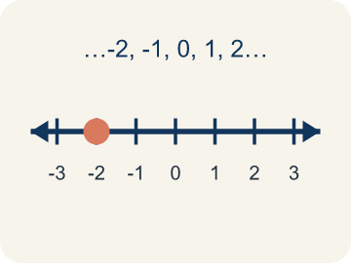 | Integer Número entero  A whole number that can be positive, negative, or zero.  Example: ... -3, -2, -1, 0, 1, 2, 3 ... shown on a number line with 0 in the center
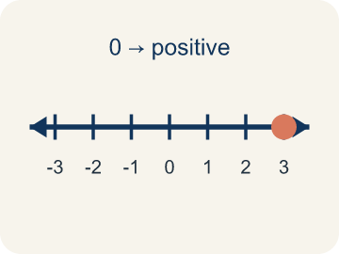 | Positive Positivo  A number bigger than zero, to the right of zero on a number line.  Example: +5 means 5 above zero, like 5 floors above ground level
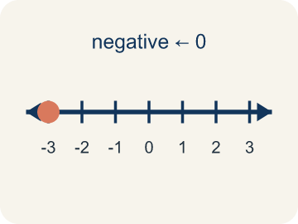 | Negative Negativo  A number smaller than zero, to the left of zero on a number line.  Example: -3 means 3 below zero, like 3 floors underground
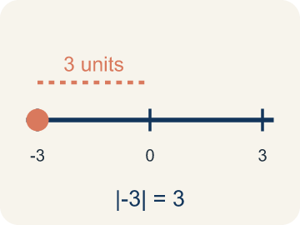 | Absolute value Valor absoluto  How far a number is from zero. It is never negative.  Example: |-5| = 5 and |5| = 5 — both are 5 units from 0
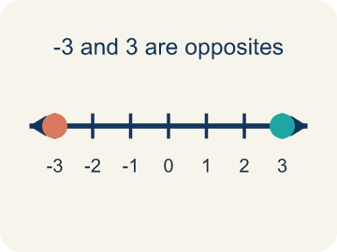 | Opposite Opuesto  Two numbers the same distance from zero, on opposite sides, like 3 and -3.  Example: 3 and -3 are opposites — both are 3 units from 0

Guided Notes
Fill in each blank as we go. Use the Word Bank to help you.
WORD BANK
Integer • Positive • Negative • Absolute value • Opposite

1. A whole number or its opposite, like −2, 0, or 5, is an ___.
2. A number greater than zero is ___.
3. A number less than zero is ___.
4. The distance of a number from zero, always positive, is its ___.
5. Two numbers the same distance from zero but on different sides, like 4 and −4, are ___.

Worked Example

Watch & Read I Do — follow along with your teacher
Treasure Map Elevation
Captain Vega's treasure map has clues hidden at different elevations! Some treasures are buried underground (below sea level) and some are on mountaintops (above sea level). Sea level is marked as 0. A treasure chest is at -4 (4 meters below sea level) and a lookout tower is at +6 (6 meters above sea level). How far is each from sea level?

Think about:
• What does the negative sign tell you about the treasure chest's location?
• Which location is farther from sea level — the chest at -4 or the tower at +6?
• How can you find the distance from sea level without worrying about direction?
• Can two different integers have the same absolute value?
• What happens to the absolute value as numbers get farther from zero?

Solved Example I Do — watch each step
Problem: What is the absolute value of -9?
A) 9
B) -9
C) 0
D) 1
Step 1: Absolute value is the distance from zero.
Step 2: -9 is 9 units from zero, so |-9| = 9.
Answer: A. 9

Guided Practice

Solve Together We Do — work with your class
Problem: Which integer has the GREATEST absolute value: -3, 7, -5, 2?
A) 7
B) -5
C) -3
D) 2
Step 1:

Step 2:

Answer:

A submarine is at -150 meters (below sea level) and a helicopter is at +200 meters (above sea level). A rescue team needs to know how far each is from sea level to plan a mission.
How does absolute value help the rescue team compare the submarine and helicopter positions?

Sentence frame: The submarine is at ___ meters, and its absolute value is ___ because ___. The helicopter is at ___ meters, and its absolute value is ___. Absolute value helps the rescue team because ___.

Turn & Talk discuss with a partner
1. [Launch] Why are -5 and 5 both the same distance from zero on the number line, even though one is negative and one is positive?
Start with: Both numbers are ___ units from zero.
Ambos numeros estan a ___ unidades del cero.
Word bank: integer, absolute value, opposite, positive, negative
2. [Explore] A diver is at -30 feet and a hawk is at +30 feet. How can absolute value help you describe how far each is from sea level?
Start with: The diver is ___ feet from sea level because |-30| = ___.
El buzo esta a ___ pies del nivel del mar porque |-30| = ___.
Word bank: integer, absolute value, positive, negative, opposite
3. [Connect] How is the opposite of a number different from the absolute value of a number?
Start with: The opposite of 7 is ___.
El opuesto de 7 es ___.
Word bank: integer, absolute value, opposite, positive, negative
4. [Reflect] Think of a real situation where a negative integer makes sense. What does zero mean in that situation?
Start with: A negative number could describe ___.
Un numero negativo podria describir ___.
Word bank: integer, negative, positive, absolute value, opposite
5. [Practice] During practice on Integers and Absolute Value, what strategy did you use when a problem felt tricky?
Start with: The diver is ___ feet from sea level because |-30| = ___.
El buzo esta a ___ pies del nivel del mar porque |-30| = ___.
Word bank: Integer, Positive, Negative, Absolute value

Independent Practice

On Your Own You Do — show your work
Solve each problem. Show your thinking in the work box.
1. What is |0|?
A) 0
B) 1
C) -1
D) There is no answer

2. Which statement about absolute value is TRUE?
A) |-4| = |4| because both are 4 units from zero
B) |-4| = -4 because the number is negative
C) |4| > |-4| because positive is always bigger
D) |-4| = 0 because negatives cancel out

3. On a frosty morning at the mountain cache, the thermometer reads -8 degrees. What is the absolute value of -8?
A) 8
B) -8
C) 0
D) 16

4. Two treasure sites report their temperatures: -5 degrees F at the Ice Cave and -2 degrees F at the Frozen Dock. Which site is COLDER?
A) -5 degrees F (Ice Cave)
B) -2 degrees F (Frozen Dock)
C) They are the same
D) Neither is below zero

Exit Ticket
Answer on your own. This shows what you learned today.
★ Which integer has an absolute value of 8 and is located to the LEFT of zero on the number line?
A) 8
B) -8
C) 0
D) -80

