Integers and Absolute Value — Homework
Lesson 9-2 • Standard 6.NOS.8
Name: ______________________ Period: ______ Date: ____________

Today's Goals
Content: I can identify integers and find their absolute value.
Language: I can explain my reasoning using the words integer, positive, negative, absolute value, and opposite.

Key Words
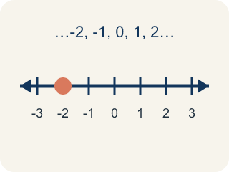
Integer (Número entero) — A whole number that can be positive, negative, or zero.
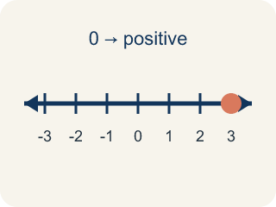
Positive (Positivo) — A number bigger than zero, to the right of zero on a number line.
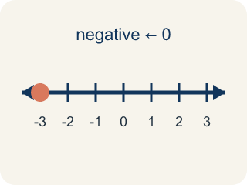
Negative (Negativo) — A number smaller than zero, to the left of zero on a number line.
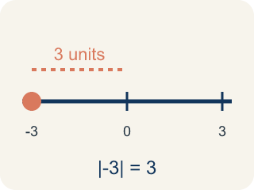
Absolute value (Valor absoluto) — How far a number is from zero. It is never negative.
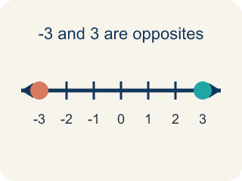
Opposite (Opuesto) — Two numbers the same distance from zero, on opposite sides, like 3 and -3.

Practice
Show your work. Use the blank space under each problem.
1. What is the absolute value of -9?
A. 9
B. -9
C. 0
D. 1
______________________________________________________________________
2. Which integer has the GREATEST absolute value: -3, 7, -5, 2?
A. 7
B. -5
C. -3
D. 2
______________________________________________________________________
3. Complete the table with each integer's absolute value and its opposite.
Integer | Absolute Value | Opposite
-7
4
-12
0
9
______________________________________________________________________
4. Sort each item into the correct group.
• undefined → __________________
• undefined → __________________
• undefined → __________________
• undefined → __________________
• undefined → __________________
• undefined → __________________
______________________________________________________________________
5. Which statement about absolute value is TRUE?
A. |-4| = |4| because both are 4 units from zero
B. |-4| = -4 because the number is negative
C. |4| > |-4| because positive is always bigger
D. |-4| = 0 because negatives cancel out
______________________________________________________________________
6. onLevel — Spot the Common Mistake
Step 1 (Read): A student is working on Integers and Absolute Value.
Step 2 (Attempt): They ignored the rule: Absolute value tells you the distance from zero, so it is always positive or zero.
Step 3 (Check): The answer does not match the math rule from class.
Which step has the mistake? Explain and fix it:
______________________________________________________________________
______________________________________________________________________
______________________________________________________________________
7. On a frosty morning at the mountain cache, the thermometer reads -8 degrees. What is the absolute value of -8?
A. 8
B. -8
C. 0
D. 16
______________________________________________________________________
8. Two treasure sites report their temperatures: -5 degrees F at the Ice Cave and -2 degrees F at the Frozen Dock. Which site is COLDER?
A. -5 degrees F (Ice Cave)
B. -2 degrees F (Frozen Dock)
C. They are the same
D. Neither is below zero
______________________________________________________________________
9. Captain Vega compares |-12| (a deep cave) and |7| (a hilltop). Which absolute value is GREATER?
A. |-12| because 12 > 7
B. |7| because 7 is positive
C. They are equal
D. |-12| = -12, so |7| is greater
______________________________________________________________________
10. Drag each treasure-site temperature into the right group: below freezing (colder than 0 degrees) or above freezing (0 degrees or warmer).
Groups: Below Freezing (colder than 0) | Freezing or Above (0 or warmer)
• -9 degrees F (Ice Cave) → __________________
• -3 degrees F (Snow Ridge) → __________________
• 5 degrees F (Tide Pool) → __________________
• 11 degrees F (Sunny Beach) → __________________
• -1 degrees F (Frozen Dock) → __________________
• 0 degrees F (Sea Level Camp) → __________________
______________________________________________________________________

Answer Key (Teacher)
1. A. 9
Absolute value is the distance from zero. -9 is 9 units from zero, so |-9| = 9.
Watch for: A common mistake in Integers and Absolute Value is skipping the key idea: "Absolute value tells you the distance from zero, so it is always positive or zero." — always check your work against this rule before you submit.
2. A. 7
|-3| = 3, |7| = 7, |-5| = 5, |2| = 2. The greatest absolute value is 7.
Watch for: A common mistake in Integers and Absolute Value is skipping the key idea: "Absolute value tells you the distance from zero, so it is always positive or zero." — always check your work against this rule before you submit.
3. Complete the table with each integer's absolute value and its opposite.
-7 — Absolute Value: 7
-7 — Opposite: 7
4 — Absolute Value: 4
4 — Opposite: -4
-12 — Absolute Value: 12
-12 — Opposite: 12
0 — Absolute Value: 0
0 — Opposite: 0
9 — Absolute Value: 9
9 — Opposite: -9

4. Correct groups:
undefined → undefined
undefined → undefined
undefined → undefined
undefined → undefined
undefined → undefined
undefined → undefined

5. A. |-4| = |4| because both are 4 units from zero
Absolute value measures distance from zero. Both -4 and 4 are 4 units from zero, so |-4| = |4| = 4.
Watch for: A common mistake in Integers and Absolute Value is skipping the key idea: "Absolute value tells you the distance from zero, so it is always positive or zero." — always check your work against this rule before you submit.
6. onLevel — Spot the Common Mistake
The mistake is in Step 2.
Correct work: Follow the key idea: Absolute value tells you the distance from zero, so it is always positive or zero.
7. A. 8
Absolute value is the distance from zero, so |-8| = 8.
Watch for: A common mistake in Integers and Absolute Value is skipping the key idea: "Absolute value tells you the distance from zero, so it is always positive or zero." — always check your work against this rule before you submit.
8. A. -5 degrees F (Ice Cave)
On a number line, -5 is to the left of -2, so -5 is the smaller (colder) temperature.
Watch for: A common mistake in Integers and Absolute Value is skipping the key idea: "Absolute value tells you the distance from zero, so it is always positive or zero." — always check your work against this rule before you submit.
9. A. |-12| because 12 > 7
|-12| = 12 and |7| = 7. Since 12 > 7, the absolute value of -12 is greater.
Watch for: A common mistake in Integers and Absolute Value is skipping the key idea: "Absolute value tells you the distance from zero, so it is always positive or zero." — always check your work against this rule before you submit.
10. Correct groups:
-9 degrees F (Ice Cave) → Below Freezing (colder than 0)
-3 degrees F (Snow Ridge) → Below Freezing (colder than 0)
5 degrees F (Tide Pool) → Freezing or Above (0 or warmer)
11 degrees F (Sunny Beach) → Freezing or Above (0 or warmer)
-1 degrees F (Frozen Dock) → Below Freezing (colder than 0)
0 degrees F (Sea Level Camp) → Freezing or Above (0 or warmer)

