UNIT 9 · LESSON 3 STANDARD 6.NS.7

Compare and Order Integers
Student Notes Packet
Name: ______________________ Date: ____________ Period: ________

Today's Goals
Content: I can compare and order integers using a number line.
Language: I can explain my reasoning using the words compare, order, greater than, and less than.

Key Vocabulary
Look at the picture, read the word, then read what it means.
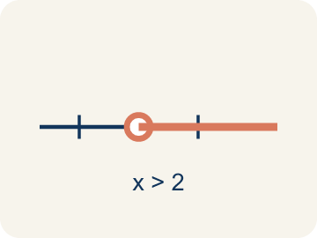 | Compare Comparar  To see if a number is bigger, smaller, or equal to another.  Example: -3 < 2 because -3 is farther left on the number line than 2
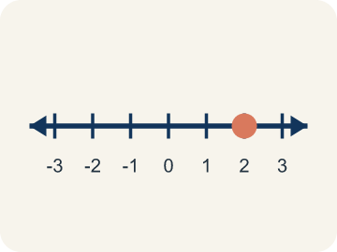 | Order Ordenar  To put numbers in order, smallest to biggest or biggest to smallest.  Example: Least to greatest: -5, -2, 0, 3, 7 (left to right on the number line)
Greater than Mayor que
Farther right on a number line. The > sign.
Example: 4 > -1 because 4 is to the right of -1 on the number line
Less than Menor que
Farther left on a number line. The < sign.
Example: -6 < -2 because -6 is farther left — it is farther from zero
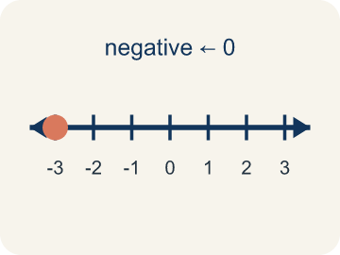 | Negative integer Entero negativo  A whole number smaller than zero, like -5.  Example: -4 is 4 units to the LEFT of zero on the number line
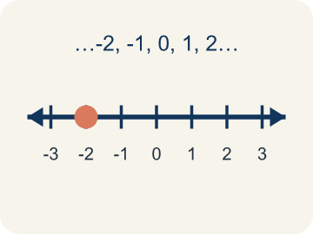 | Integer Número entero  Whole numbers and their opposites, like -2, -1, 0, 1, 2.  Example: ..., -3, -2, -1, 0, 1, 2, 3, ...

Guided Notes
Fill in each blank as we go. Use the Word Bank to help you.
WORD BANK
Compare • Order • Greater than • Less than • Negative integer • Integer

1. To decide which number is larger or smaller is to ___ them.
2. To arrange numbers from least to greatest or greatest to least is to ___ them.
3. On a number line, a number farther to the right is ___ another number.
4. On a number line, a number farther to the left is ___ another number.
5. An integer less than zero, like −6, is a ___.
6. A whole number or its opposite is an ___.

Worked Example

Watch & Read I Do — follow along with your teacher
Ranking Treasure Depths
Captain Vega's crew found treasures at different depths underwater! The deeper the treasure, the more negative the elevation. A gold coin is at -2 meters, a silver crown is at -7 meters, and a ruby ring is at -5 meters. The crew needs to rank them from the shallowest (closest to the surface) to the deepest.

Think about:
• Which treasure is closest to the surface?
• Is -7 greater than or less than -2?
• How does the number line help you compare negative numbers?
• Why does a bigger negative number mean a deeper location?
• What if one treasure was above water — how would you compare it to the underwater ones?

Solved Example I Do — watch each step
Problem: Which statement is TRUE?
A) -3 > -1
B) -5 < -2
C) -4 > 0
D) -1 < -6
Step 1: -5 is farther to the left on the number line than -2, so -5 < -2 is true.
Answer: B. -5 < -2

Guided Practice

Solve Together We Do — work with your class
Problem: Which integer is the LEAST: -3, 5, -8, 2, 0?
A) -8
B) -3
C) 0
D) 5
Step 1:

Step 2:

Answer:

A weather station recorded these temperatures during a winter week: Monday -4°F, Tuesday 2°F, Wednesday -7°F, Thursday -1°F, Friday 5°F. The station needs to report the coldest and warmest days.
How do you use integer comparison to find the coldest and warmest days?

Sentence frame: The coldest day was ___ at ___°F because ___. The warmest day was ___ at ___°F. I ordered them from coldest to warmest by ___.

Turn & Talk discuss with a partner
1. [Launch] Why is -3 less than 2, even though 3 looks like a bigger number than 2?
Start with: On the number line, -3 is to the ___ of 2.
En la recta numerica, -3 esta a la ___ de 2.
Word bank: integer, compare, number line, less than, greater than
2. [Explore] Order these temperatures from coldest to warmest: -8, 3, -1, 5. How does the number line help you put them in order?
Start with: The coldest temperature is ___ because it is farthest ___.
La temperatura mas fria es ___ porque esta mas a la ___.
Word bank: integer, order, compare, number line, least to greatest
3. [Connect] How does knowing a number's position on the number line tell you whether to use the < or > symbol?
Start with: The number on the left is ___ than the number on the right.
El numero de la izquierda es ___ que el numero de la derecha.
Word bank: compare, order, number line, less than, greater than
4. [Reflect] Two students disagree: one says -10 is greater than -2 because 10 is bigger. Who is right, and how do you know?
Start with: -10 is actually ___ than -2.
-10 en realidad es ___ que -2.
Word bank: integer, compare, number line, less than, greater than
5. [Practice] During practice on Compare and Order Integers, what strategy did you use when a problem felt tricky?
Start with: The coldest temperature is ___ because it is farthest ___.
La temperatura mas fria es ___ porque esta mas a la ___.
Word bank: Compare, Order, Greater than, Less than

Independent Practice

On Your Own You Do — show your work
Solve each problem. Show your thinking in the work box.
1. What is |−8|?
A) 8
B) −8
C) 0
D) −16

2. Three cities have temperatures of -12°F, -5°F, and 3°F. Which city is warmest?
A) 3°F
B) -5°F
C) -12°F
D) They are equal

3. The crew marks four spots on the map: a tide pool at -3 m, a flag at 2 m, a cave at -7 m, and the boat deck at 0 m. Order them from least to greatest (deepest to highest).
A) -7, -3, 0, 2
B) -3, -7, 0, 2
C) 2, 0, -3, -7
D) -7, -3, 2, 0

4. Three buried chests sit at -9 m, -4 m, and -15 m below sea level. Which chest is at the GREATEST elevation (closest to the surface)?
A) -4 m
B) -9 m
C) -15 m
D) They are equal

Exit Ticket
Answer on your own. This shows what you learned today.
★ Which list shows the integers in order from LEAST to GREATEST?
A) -2, -5, 0, 3, 7
B) 7, 3, 0, -2, -5
C) -5, -2, 0, 3, 7
D) 0, -2, -5, 3, 7

