Compare and Order Integers — Homework
Lesson 9-3 • Standard 6.NOS.8
Name: ______________________ Period: ______ Date: ____________

Today's Goals
Content: I can compare and order integers using a number line.
Language: I can explain my reasoning using the words compare, order, greater than, and less than.

Key Words
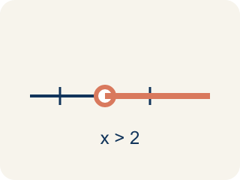
Compare (Comparar) — To see if a number is bigger, smaller, or equal to another.
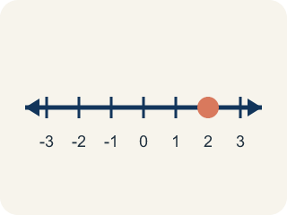
Order (Ordenar) — To put numbers in order, smallest to biggest or biggest to smallest.
Greater than (Mayor que) — Farther right on a number line. The > sign.
Less than (Menor que) — Farther left on a number line. The < sign.
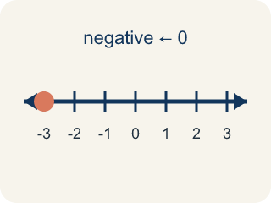
Negative integer (Entero negativo) — A whole number smaller than zero, like -5.
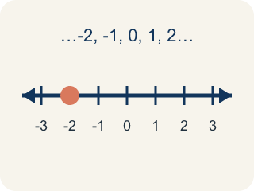
Integer (Número entero) — Whole numbers and their opposites, like -2, -1, 0, 1, 2.

Practice
Show your work. Use the blank space under each problem.
1. Which statement is TRUE?
A. -3 > -1
B. -5 < -2
C. -4 > 0
D. -1 < -6
______________________________________________________________________
2. Which integer is the LEAST: -3, 5, -8, 2, 0?
A. -8
B. -3
C. 0
D. 5
______________________________________________________________________
3. Compare each pair of integers using < , > , or =.
Integer A | Integer B | Comparison (< , > , or =)
-4 | 2
-7 | -3
0 | -5
-1 | -1
6 | -9
______________________________________________________________________
4. Sort each item into the correct group.
• undefined → __________________
• undefined → __________________
• undefined → __________________
• undefined → __________________
• undefined → __________________
• undefined → __________________
______________________________________________________________________
5. Three cities have temperatures of -12°F, -5°F, and 3°F. Which city is warmest?
A. 3°F
B. -5°F
C. -12°F
D. They are equal
______________________________________________________________________
6. onLevel — Spot the Common Mistake
Step 1 (Read): A student is working on Compare and Order Integers.
Step 2 (Attempt): They ignored the rule: The number farther to the left is always less; the number farther to the right is always greater.
Step 3 (Check): The answer does not match the math rule from class.
Which step has the mistake? Explain and fix it:
______________________________________________________________________
______________________________________________________________________
______________________________________________________________________
7. The crew marks four spots on the map: a tide pool at -3 m, a flag at 2 m, a cave at -7 m, and the boat deck at 0 m. Order them from least to greatest (deepest to highest).
A. -7, -3, 0, 2
B. -3, -7, 0, 2
C. 2, 0, -3, -7
D. -7, -3, 2, 0
______________________________________________________________________
8. Three buried chests sit at -9 m, -4 m, and -15 m below sea level. Which chest is at the GREATEST elevation (closest to the surface)?
A. -4 m
B. -9 m
C. -15 m
D. They are equal
______________________________________________________________________
9. On the map, a sunken lantern is at -8 m and a coral shelf is at -3 m. Which symbol makes the comparison true: -8 ___ -3 ?
A. <
B. >
C. =
D. ≥
______________________________________________________________________
10. Sort each treasure marker into the right zone on the map: below sea level or above sea level.
Groups: Less than 0 (below sea level) | Greater than 0 (above sea level)
• -6 m shipwreck → __________________
• 4 m cliff nest → __________________
• -1 m anchor → __________________
• 7 m crow's nest → __________________
• -12 m trench chest → __________________
• 3 m palm flag → __________________
______________________________________________________________________

Answer Key (Teacher)
1. B. -5 < -2
-5 is farther to the left on the number line than -2, so -5 < -2 is true.
Watch for: A common mistake in Compare and Order Integers is skipping the key idea: "The number farther to the left is always less; the number farther to the right is always greater." — always check your work against this rule before you submit.
2. A. -8
-8 is farthest to the left on the number line, making it the least (smallest) integer.
Watch for: A common mistake in Compare and Order Integers is skipping the key idea: "The number farther to the left is always less; the number farther to the right is always greater." — always check your work against this rule before you submit.
3. Compare each pair of integers using < , > , or =.
-4 — Comparison (< , > , or =): <
-7 — Comparison (< , > , or =): <
0 — Comparison (< , > , or =): >
-1 — Comparison (< , > , or =): =
6 — Comparison (< , > , or =): >

4. Correct groups:
undefined → undefined
undefined → undefined
undefined → undefined
undefined → undefined
undefined → undefined
undefined → undefined

5. A. 3°F
3°F is the greatest because it is farthest to the right on the number line. The order from coldest to warmest is -12, -5, 3.
Watch for: A common mistake in Compare and Order Integers is skipping the key idea: "The number farther to the left is always less; the number farther to the right is always greater." — always check your work against this rule before you submit.
6. onLevel — Spot the Common Mistake
The mistake is in Step 2.
Correct work: Follow the key idea: The number farther to the left is always less; the number farther to the right is always greater.
7. A. -7, -3, 0, 2
The deepest spot is the cave at -7 (farthest left), then the tide pool -3, then the boat deck 0, then the flag at 2. Least to greatest: -7, -3, 0, 2.
Watch for: A common mistake in Compare and Order Integers is skipping the key idea: "The number farther to the left is always less; the number farther to the right is always greater." — always check your work against this rule before you submit.
8. A. -4 m
Closer to zero means greater for negatives. -4 is only 4 below the surface, so -4 is the greatest of -9, -4, and -15.
Watch for: A common mistake in Compare and Order Integers is skipping the key idea: "The number farther to the left is always less; the number farther to the right is always greater." — always check your work against this rule before you submit.
9. A. <
-8 is farther left (deeper) than -3, so -8 is less than -3. The symbol is <.
Watch for: A common mistake in Compare and Order Integers is skipping the key idea: "The number farther to the left is always less; the number farther to the right is always greater." — always check your work against this rule before you submit.
10. Correct groups:
-6 m shipwreck → Less than 0 (below sea level)
4 m cliff nest → Greater than 0 (above sea level)
-1 m anchor → Less than 0 (below sea level)
7 m crow's nest → Greater than 0 (above sea level)
-12 m trench chest → Less than 0 (below sea level)
3 m palm flag → Greater than 0 (above sea level)

