UNIT 9 · LESSON 4 STANDARD 6.NS.6

Rational Numbers on the Number Line
Student Notes Packet
Name: ______________________ Date: ____________ Period: ________

Today's Goals
Content: I can place rational numbers, including fractions and decimals, on a number line.
Language: I can explain my reasoning using the words rational number, fraction, decimal, and number line.

Key Vocabulary
Look at the picture, read the word, then read what it means.
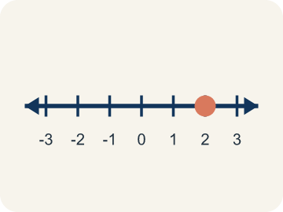 | Rational number Número racional  Any number you can write as a fraction. This includes fractions, decimals, and integers.  Example: 1/2 = 0.5, -3/4 = -0.75, 6 = 6/1 — all rational numbers
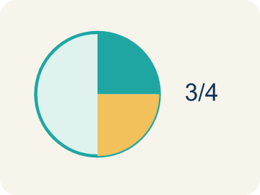 | Fraction Fracción  A number that shows part of a whole, like 3/4.  Example: 3/4 means 3 out of 4 equal parts — like 3 slices of a pizza cut into 4
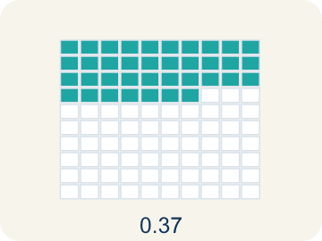 | Decimal Decimal  A number with a dot, like 0.5, that shows a part less than one.  Example: 0.5 = 1/2 (halfway between 0 and 1 on the number line)
Number line Recta numérica
A straight line with numbers spaced out evenly.
Example: A line with marks at -2, -1.5, -1, -0.5, 0, 0.5, 1, 1.5, 2
Equivalent Equivalente
Having the same value, just written a different way.
Example: 1/2 = 0.5 = 2/4 — all name the same point on the number line
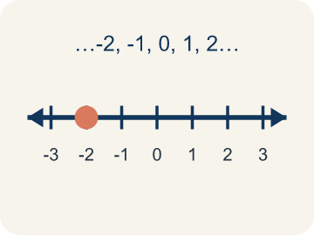 | Integer Número entero  Whole numbers and their opposites, like -2, -1, 0, 1, 2.  Example: ..., -3, -2, -1, 0, 1, 2, 3, ...

Guided Notes
Fill in each blank as we go. Use the Word Bank to help you.
WORD BANK
Rational number • Fraction • Decimal • Number line • Equivalent • Integer

1. Any number that can be written as a fraction, including integers and decimals, is a ___.
2. A number that shows part of a whole, like 3/5, is a ___.
3. A number that uses a point to show parts of a whole is a ___.
4. A line with numbers in order used to place and compare values is a ___.
5. Numbers that name the same value, like 1/2 and 0.5, are ___.
6. A whole number or its opposite is an ___.

Worked Example

Watch & Read I Do — follow along with your teacher
Precise Treasure Coordinates
Captain Vega's advanced treasure map uses precise coordinates — not just whole numbers! One clue says the treasure is at -2.5 on the map (halfway between -2 and -3). Another clue points to 3/4 of the way from 0 to 1. A third clue leads to -1 1/2. To find each treasure, you must plot these exact rational numbers on the number line.

Think about:
• Where would -2.5 fall on a number line between -3 and -2?
• How is plotting 3/4 different from plotting a whole number?
• Can a negative number be a fraction or decimal?
• How many rational numbers exist between any two integers?
• Are there numbers that are NOT rational?

Solved Example I Do — watch each step
Problem: Which point is located between -1 and -2 on the number line?
A) -0.5
B) -1.5
C) -2.5
D) 1.5
Step 1: -1.5 is between -1 and -2 because it is 0.5 units to the left of -1 (or 0.5 units to the right of -2).
Answer: B. -1.5

Guided Practice

Solve Together We Do — work with your class
Problem: Which fraction is equivalent to 0.25?
A) 1/4
B) 1/2
C) 2/5
D) 1/3
Step 1:

Step 2:

Answer:

A scientist measures the water level of a lake relative to normal level (0). Monday: +0.75 ft, Tuesday: -1.25 ft, Wednesday: -0.5 ft, Thursday: +1.5 ft. She needs to plot these on a graph to track changes.
How do rational numbers help the scientist describe water levels more precisely than integers alone?

Sentence frame: Rational numbers help because ___. For example, -1.25 ft means the water is ___ below normal, which is between ___ and ___ on the number line. Without fractions and decimals, the scientist could only say ___.

Turn & Talk discuss with a partner
1. [Launch] How can a fraction like 1/2, a decimal like 0.75, and an integer like -3 all be rational numbers?
Start with: A rational number is any number you can write as ___.
Un numero racional es cualquier numero que puedes escribir como ___.
Word bank: rational number, fraction, decimal, integer, number line
2. [Explore] Where would you place -1 1/2 on the number line, and how do you decide between which two integers it falls?
Start with: -1 1/2 is between ___ and ___.
-1 1/2 esta entre ___ y ___.
Word bank: rational number, fraction, number line, integer, negative
3. [Connect] How can rewriting a fraction as a decimal (or a decimal as a fraction) help you compare two rational numbers?
Start with: If I turn 3/4 into a decimal, I get ___.
Si convierto 3/4 en decimal, obtengo ___.
Word bank: rational number, fraction, decimal, compare, number line
4. [Reflect] Is every integer a rational number? Is every rational number an integer? Explain your thinking.
Start with: Every integer is rational because it can be written as ___.
Todo entero es racional porque se puede escribir como ___.
Word bank: rational number, integer, fraction, decimal, number line
5. [Practice] During practice on Rational Numbers on the Number Line, what strategy did you use when a problem felt tricky?
Start with: -1 1/2 is between ___ and ___.
-1 1/2 esta entre ___ y ___.
Word bank: Rational number, Fraction, Decimal, Number line

Independent Practice

On Your Own You Do — show your work
Solve each problem. Show your thinking in the work box.
1. Where is -3/4 located on the number line?
A) Between 0 and -1
B) Between -3 and -4
C) Between -1 and -2
D) Between 0 and 1

2. Which rational number is closest to 0 on the number line?
A) -1/4
B) 0.5
C) -2
D) 1.75

3. The first trail marker sits between 0 and 1. Which rational number belongs there?
A) 3/4
B) 1.5
C) -1/2
D) 2

4. Order these three trail markers from least to greatest: -1.5, 0.5, -0.5.
A) -1.5, -0.5, 0.5
B) 0.5, -0.5, -1.5
C) -0.5, -1.5, 0.5
D) -1.5, 0.5, -0.5

Exit Ticket
Answer on your own. This shows what you learned today.
★ Which rational number is located between -2 and -3 on the number line?
A) -1.5
B) -2.75
C) -3.5
D) 2.5

