Rational Numbers on the Number Line — Homework
Lesson 9-4 • Standard 6.NOS.6
Name: ______________________ Period: ______ Date: ____________

Today's Goals
Content: I can place rational numbers, including fractions and decimals, on a number line.
Language: I can explain my reasoning using the words rational number, fraction, decimal, and number line.

Key Words
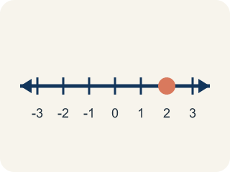
Rational number (Número racional) — Any number you can write as a fraction. This includes fractions, decimals, and integers.
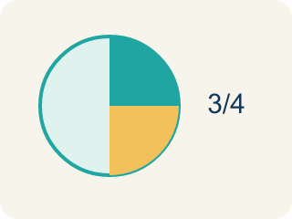
Fraction (Fracción) — A number that shows part of a whole, like 3/4.
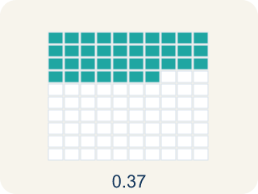
Decimal (Decimal) — A number with a dot, like 0.5, that shows a part less than one.
Number line (Recta numérica) — A straight line with numbers spaced out evenly.
Equivalent (Equivalente) — Having the same value, just written a different way.
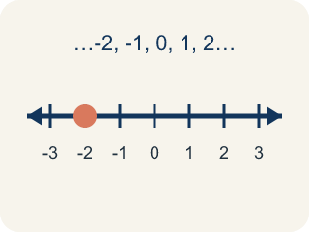
Integer (Número entero) — Whole numbers and their opposites, like -2, -1, 0, 1, 2.

Practice
Show your work. Use the blank space under each problem.
1. Which point is located between -1 and -2 on the number line?
A. -0.5
B. -1.5
C. -2.5
D. 1.5
______________________________________________________________________
2. Which fraction is equivalent to 0.25?
A. 1/4
B. 1/2
C. 2/5
D. 1/3
______________________________________________________________________
3. Convert between fraction and decimal form. Then plot on a mental number line to compare.
Fraction | Decimal | Between Which Two Integers?
3/4
-7/2
 | 0.6
 | -1.25
2 1/5
______________________________________________________________________
4. Sort each item into the correct group.
• undefined → __________________
• undefined → __________________
• undefined → __________________
• undefined → __________________
• undefined → __________________
• undefined → __________________
______________________________________________________________________
5. Which rational number is closest to 0 on the number line?
A. -1/4
B. 0.5
C. -2
D. 1.75
______________________________________________________________________
6. onLevel — Spot the Common Mistake
Step 1 (Read): A student is working on Rational Numbers on the Number Line.
Step 2 (Attempt): They ignored the rule: To plot a rational number, find the two whole numbers it falls between, then split the space into equal parts.
Step 3 (Check): The answer does not match the math rule from class.
Which step has the mistake? Explain and fix it:
______________________________________________________________________
______________________________________________________________________
______________________________________________________________________
7. The first trail marker sits between 0 and 1. Which rational number belongs there?
A. 3/4
B. 1.5
C. -1/2
D. 2
______________________________________________________________________
8. Order these three trail markers from least to greatest: -1.5, 0.5, -0.5.
A. -1.5, -0.5, 0.5
B. 0.5, -0.5, -1.5
C. -0.5, -1.5, 0.5
D. -1.5, 0.5, -0.5
______________________________________________________________________
9. On the trail map, -3/4 sits to the LEFT of which marker?
A. -1/4
B. -1
C. -2
D. -7/8
______________________________________________________________________
10. Match each decimal trail marker to its equal fraction.
Item | Answer choices
____ 0.5 | D. 1/5
____ 0.25 | C. -1/2
____ -0.5 | B. 1/4
____ 0.2 | A. 1/2
______________________________________________________________________

Answer Key (Teacher)
1. B. -1.5
-1.5 is between -1 and -2 because it is 0.5 units to the left of -1 (or 0.5 units to the right of -2).
Watch for: A common mistake in Rational Numbers on the Number Line is skipping the key idea: "To plot a rational number, find the two whole numbers it falls between, then split the space into equal parts." — always check your work against this rule before you submit.
2. A. 1/4
0.25 means 25 hundredths = 25/100 = 1/4.
Watch for: A common mistake in Rational Numbers on the Number Line is skipping the key idea: "To plot a rational number, find the two whole numbers it falls between, then split the space into equal parts." — always check your work against this rule before you submit.
3. Convert between fraction and decimal form. Then plot on a mental number line to compare.
3/4 — Decimal: 0.75
3/4 — Between Which Two Integers?: 0 and 1
-7/2 — Decimal: -3.5
-7/2 — Between Which Two Integers?: -4 and -3
Row 3 — Fraction: 3/5
Row 3 — Between Which Two Integers?: 0 and 1
Row 4 — Fraction: -1 1/4
Row 4 — Between Which Two Integers?: -2 and -1
2 1/5 — Decimal: 2.2
2 1/5 — Between Which Two Integers?: 2 and 3

4. Correct groups:
undefined → undefined
undefined → undefined
undefined → undefined
undefined → undefined
undefined → undefined
undefined → undefined

5. A. -1/4
|-1/4| = 0.25, |0.5| = 0.5, |-2| = 2, |1.75| = 1.75. Since 0.25 is the smallest absolute value, -1/4 is closest to zero.
Watch for: A common mistake in Rational Numbers on the Number Line is skipping the key idea: "To plot a rational number, find the two whole numbers it falls between, then split the space into equal parts." — always check your work against this rule before you submit.
6. onLevel — Spot the Common Mistake
The mistake is in Step 2.
Correct work: Follow the key idea: To plot a rational number, find the two whole numbers it falls between, then split the space into equal parts.
7. A. 3/4
3/4 = 0.75, which lands between 0 and 1. 1.5 and 2 are larger, and -1/2 is to the left of 0.
Watch for: A common mistake in Rational Numbers on the Number Line is skipping the key idea: "To plot a rational number, find the two whole numbers it falls between, then split the space into equal parts." — always check your work against this rule before you submit.
8. A. -1.5, -0.5, 0.5
The farthest left on the number line comes first: -1.5, then -0.5, then 0.5.
Watch for: A common mistake in Rational Numbers on the Number Line is skipping the key idea: "To plot a rational number, find the two whole numbers it falls between, then split the space into equal parts." — always check your work against this rule before you submit.
9. A. -1/4
-3/4 = -0.75 and -1/4 = -0.25. Since -0.75 is farther left (less), -3/4 is to the left of -1/4.
Watch for: A common mistake in Rational Numbers on the Number Line is skipping the key idea: "To plot a rational number, find the two whole numbers it falls between, then split the space into equal parts." — always check your work against this rule before you submit.
10. Matches:
0.5 → 1/2
0.25 → 1/4
-0.5 → -1/2
0.2 → 1/5

