UNIT 9 · LESSON 5 STANDARD 6.NS.6B

Ordered Pairs in All Four Quadrants
Student Notes Packet
Name: ______________________ Date: ____________ Period: ________

Today's Goals
Content: I can plot ordered pairs in all four quadrants of the coordinate plane.
Language: I can explain my work using the words quadrant, negative coordinate, reflection, and axis.

Key Vocabulary
Look at the picture, read the word, then read what it means.
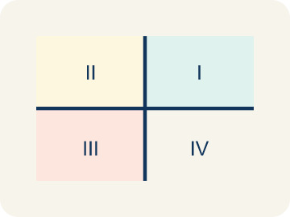 | Quadrant Cuadrante  One of the four parts of a coordinate grid, numbered I to IV.  Example: I (+, +) top-right, II (-, +) top-left, III (-, -) bottom-left, IV (+, -) bottom-right
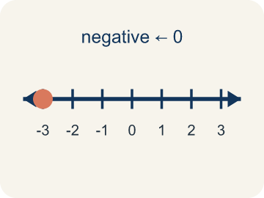 | Negative coordinate Coordenada negativa  A coordinate less than zero. It means left or below the center point.  Example: (-3, 2) means 3 left and 2 up from the origin
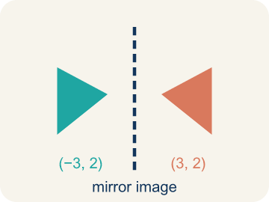 | Reflection Reflexión  A flipped, mirror image of a point across a line.  Example: (3, 2) reflected over the y-axis is (-3, 2) — same distance, opposite side
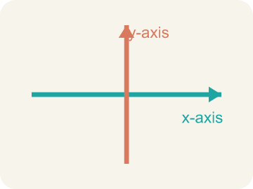 | Axis Eje  A line on the grid. The x-axis goes across; the y-axis goes up.  Example: The x-axis goes left-right; the y-axis goes up-down; they cross at (0, 0)
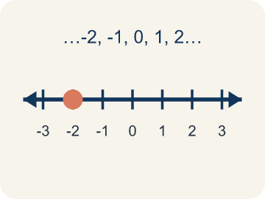 | Integer Número entero  Whole numbers and their opposites, like -2, -1, 0, 1, 2.  Example: ..., -3, -2, -1, 0, 1, 2, 3, ...

Guided Notes
Fill in each blank as we go. Use the Word Bank to help you.
WORD BANK
Quadrant • Negative coordinate • Reflection • Axis • Integer

1. One of the four regions of the coordinate plane, numbered I to IV, is a ___.
2. A coordinate less than zero, which places a point left of or below the origin, is a ___.
3. A flip of a point over an axis is a ___.
4. One of the two number lines, the x-axis or y-axis, that form the grid is an ___.
5. A whole number or its opposite is an ___.

Worked Example

Watch & Read I Do — follow along with your teacher
Expanding the Treasure Map
Captain Vega realized her treasure map only covered one corner of the island! She needs to expand the map in all directions — north, south, east, and west of the base camp at the origin (0, 0). Now clues can have negative coordinates: (-4, 3) means 4 units west and 3 units north. A clue at (2, -5) means 2 units east and 5 units south. Which quadrant is each clue in?

Think about:
• How do you know which quadrant a point is in by looking at the signs of its coordinates?
• What do negative x-values and negative y-values mean on the map?
• Where is the point (0, 0) on the expanded map?
• Can a point be in more than one quadrant?
• What quadrant is a point on if one of its coordinates is zero?

Solved Example I Do — watch each step
Problem: In which quadrant is the point (-4, 5)?
A) Quadrant I
B) Quadrant II
C) Quadrant III
D) Quadrant IV
Step 1: The x-coordinate is negative (left) and the y-coordinate is positive (up).
Step 2: Left and up is Quadrant II.
Answer: B. Quadrant II

Guided Practice

Solve Together We Do — work with your class
Problem: A point has a positive x-coordinate and a negative y-coordinate. Which quadrant is it in?
A) Quadrant I
B) Quadrant II
C) Quadrant III
D) Quadrant IV
Step 1:

Step 2:

Answer:

A city uses a coordinate grid to map locations. City Hall is at the origin (0, 0). The library is at (-3, 4), the park is at (5, -2), the school is at (2, 3), and the hospital is at (-4, -1).
How do four-quadrant coordinates help a city map locations in every direction from the center?

Sentence frame: The library is in Quadrant ___ because its x is ___ and its y is ___. The park is in Quadrant ___ because ___. Four-quadrant coordinates help because ___.

Turn & Talk discuss with a partner
1. [Launch] What do the signs of the coordinates in an ordered pair tell you about which quadrant the point is in?
Start with: If both coordinates are positive, the point is in quadrant ___.
Si ambas coordenadas son positivas, el punto esta en el cuadrante ___.
Word bank: quadrant, ordered pair, negative coordinate, x-axis, y-axis
2. [Explore] Plot (-3, -4). Which quadrant is it in, and how do the negative coordinates change the directions you move from the origin?
Start with: A negative x means I move ___.
Una x negativa significa que me muevo ___.
Word bank: quadrant, negative coordinate, ordered pair, x-axis, y-axis
3. [Connect] How are the four quadrants like a tic-tac-toe of positive and negative directions on the coordinate plane?
Start with: Quadrant ___ has both coordinates positive.
El cuadrante ___ tiene ambas coordenadas positivas.
Word bank: quadrant, negative coordinate, ordered pair, x-axis, y-axis
4. [Reflect] A point has coordinates (5, -2). Without plotting, how can you describe exactly where it is and which quadrant it is in?
Start with: The point is ___ of the y-axis and ___ of the x-axis.
El punto esta a la ___ del eje y y ___ del eje x.
Word bank: quadrant, ordered pair, negative coordinate, x-axis, y-axis
5. [Practice] During practice on Ordered Pairs in All Four Quadrants, what strategy did you use when a problem felt tricky?
Start with: A negative x means I move ___.
Una x negativa significa que me muevo ___.
Word bank: Quadrant, Negative coordinate, Reflection, Axis

Independent Practice

On Your Own You Do — show your work
Solve each problem. Show your thinking in the work box.
1. Which point is located on the x-axis?
A) (4, 0)
B) (0, 4)
C) (4, 4)
D) (-4, -4)

2. Point A is at (-5, 3). If you move 8 units to the right, what are the new coordinates?
A) (3, 3)
B) (-13, 3)
C) (-5, 11)
D) (-5, -5)

3. A sonar ping locates an enemy submarine at (-5, -2). In which quadrant should Captain Vega aim her shot?
A) Quadrant I
B) Quadrant II
C) Quadrant III
D) Quadrant IV

4. Captain Vega's lookout reports a ship in Quadrant II. What signs will its coordinates (x, y) have?
A) (+, +)
B) (-, +)
C) (-, -)
D) (+, -)

Exit Ticket
Answer on your own. This shows what you learned today.
★ A point has a negative x-coordinate and a negative y-coordinate. Which quadrant is it in?
A) Quadrant I
B) Quadrant II
C) Quadrant III
D) Quadrant IV

