Ordered Pairs in All Four Quadrants — Homework
Lesson 9-5 • Standard 6.NOS.7
Name: ______________________ Period: ______ Date: ____________

Today's Goals
Content: I can plot ordered pairs in all four quadrants of the coordinate plane.
Language: I can explain my work using the words quadrant, negative coordinate, reflection, and axis.

Key Words
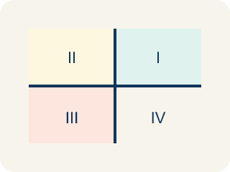
Quadrant (Cuadrante) — One of the four parts of a coordinate grid, numbered I to IV.
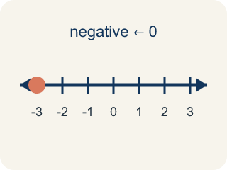
Negative coordinate (Coordenada negativa) — A coordinate less than zero. It means left or below the center point.
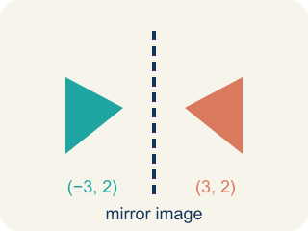
Reflection (Reflexión) — A flipped, mirror image of a point across a line.
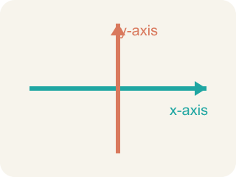
Axis (Eje) — A line on the grid. The x-axis goes across; the y-axis goes up.
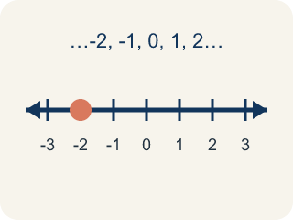
Integer (Número entero) — Whole numbers and their opposites, like -2, -1, 0, 1, 2.

Practice
Show your work. Use the blank space under each problem.
1. In which quadrant is the point (-4, 5)?
A. Quadrant I
B. Quadrant II
C. Quadrant III
D. Quadrant IV
______________________________________________________________________
2. A point has a positive x-coordinate and a negative y-coordinate. Which quadrant is it in?
A. Quadrant I
B. Quadrant II
C. Quadrant III
D. Quadrant IV
______________________________________________________________________
3. For each ordered pair, write the signs of x and y and name the quadrant (or axis).
Point | x sign | y sign | Quadrant or Axis
(6, -2)
(-3, -5)
(0, 7)
(-1, 8)
(4, 0)
______________________________________________________________________
4. Match each quadrant to its coordinate sign pattern.
Item | Answer choices
____ Quadrant I | F. x = 0
____ Quadrant II | E. y = 0
____ Quadrant III | D. (+, -)
____ Quadrant IV | C. (-, -)
____ x-axis | B. (-, +)
____ y-axis | A. (+, +)
______________________________________________________________________
5. Point A is at (-5, 3). If you move 8 units to the right, what are the new coordinates?
A. (3, 3)
B. (-13, 3)
C. (-5, 11)
D. (-5, -5)
______________________________________________________________________
6. onLevel — Spot the Common Mistake
Step 1 (Read): A student is working on Ordered Pairs in All Four Quadrants.
Step 2 (Attempt): They ignored the rule: The signs of (x, y) tell you the quadrant: (+,+) is I, (-,+) is II, (-,-) is III, (+,-) is IV.
Step 3 (Check): The answer does not match the math rule from class.
Which step has the mistake? Explain and fix it:
______________________________________________________________________
______________________________________________________________________
______________________________________________________________________
7. Captain Vega spotted four enemy ships. Drag each ship's coordinates into the correct quadrant of the map.
Groups: Quadrant I | Quadrant II | Quadrant III | Quadrant IV
• (3, 2) → __________________
• (-4, 1) → __________________
• (-2, -5) → __________________
• (6, -3) → __________________
______________________________________________________________________
8. A sonar ping locates an enemy submarine at (-5, -2). In which quadrant should Captain Vega aim her shot?
A. Quadrant I
B. Quadrant II
C. Quadrant III
D. Quadrant IV
______________________________________________________________________
9. Captain Vega's lookout reports a ship in Quadrant II. What signs will its coordinates (x, y) have?
A. (+, +)
B. (-, +)
C. (-, -)
D. (+, -)
______________________________________________________________________
10. Match each enemy ship's coordinates to the quadrant where Captain Vega should fire.
Item | Answer choices
____ (7, 5) | D. Quadrant IV
____ (-6, 2) | C. Quadrant III
____ (-1, -8) | B. Quadrant II
____ (4, -7) | A. Quadrant I
______________________________________________________________________

Answer Key (Teacher)
1. B. Quadrant II
The x-coordinate is negative (left) and the y-coordinate is positive (up). Left and up is Quadrant II.
Watch for: A common mistake in Ordered Pairs in All Four Quadrants is skipping the key idea: "The signs of (x, y) tell you the quadrant: (+,+) is I, (-,+) is II, (-,-) is III, (+,-) is IV." — always check your work against this rule before you submit.
2. D. Quadrant IV
Positive x (right) and negative y (down) = Quadrant IV (bottom-right).
Watch for: A common mistake in Ordered Pairs in All Four Quadrants is skipping the key idea: "The signs of (x, y) tell you the quadrant: (+,+) is I, (-,+) is II, (-,-) is III, (+,-) is IV." — always check your work against this rule before you submit.
3. For each ordered pair, write the signs of x and y and name the quadrant (or axis).
(6, -2) — x sign: +
(6, -2) — y sign: -
(6, -2) — Quadrant or Axis: IV
(-3, -5) — x sign: -
(-3, -5) — y sign: -
(-3, -5) — Quadrant or Axis: III
(0, 7) — x sign: 0
(0, 7) — y sign: +
(0, 7) — Quadrant or Axis: y-axis
(-1, 8) — x sign: -
(-1, 8) — y sign: +
(-1, 8) — Quadrant or Axis: II
(4, 0) — x sign: +
(4, 0) — y sign: 0
(4, 0) — Quadrant or Axis: x-axis

4. Matches:
Quadrant I → (+, +)
Quadrant II → (-, +)
Quadrant III → (-, -)
Quadrant IV → (+, -)
x-axis → y = 0
y-axis → x = 0

5. A. (3, 3)
Moving right means adding to the x-coordinate: -5 + 8 = 3. The y stays the same. New point: (3, 3).
Watch for: A common mistake in Ordered Pairs in All Four Quadrants is skipping the key idea: "The signs of (x, y) tell you the quadrant: (+,+) is I, (-,+) is II, (-,-) is III, (+,-) is IV." — always check your work against this rule before you submit.
6. onLevel — Spot the Common Mistake
The mistake is in Step 2.
Correct work: Follow the key idea: The signs of (x, y) tell you the quadrant: (+,+) is I, (-,+) is II, (-,-) is III, (+,-) is IV.
7. Correct groups:
(3, 2) → Quadrant I
(-4, 1) → Quadrant II
(-2, -5) → Quadrant III
(6, -3) → Quadrant IV

8. C. Quadrant III
A negative x means left and a negative y means down, so (-5, -2) is in Quadrant III, where both coordinates are negative.
Watch for: A common mistake in Ordered Pairs in All Four Quadrants is skipping the key idea: "The signs of (x, y) tell you the quadrant: (+,+) is I, (-,+) is II, (-,-) is III, (+,-) is IV." — always check your work against this rule before you submit.
9. B. (-, +)
Quadrant II is up and to the left of the origin, so x is negative and y is positive: (-, +).
Watch for: A common mistake in Ordered Pairs in All Four Quadrants is skipping the key idea: "The signs of (x, y) tell you the quadrant: (+,+) is I, (-,+) is II, (-,-) is III, (+,-) is IV." — always check your work against this rule before you submit.
10. Matches:
(7, 5) → Quadrant I
(-6, 2) → Quadrant II
(-1, -8) → Quadrant III
(4, -7) → Quadrant IV

