Distance on the Coordinate Plane — Homework
Lesson 9-6 • Standard 6.NOS.9
Name: ______________________ Period: ______ Date: ____________

Today's Goals
Content: I can find the distance between two points on the coordinate plane using absolute value.
Language: I can explain my work using the words distance, absolute value, horizontal distance, and vertical distance.

Key Words
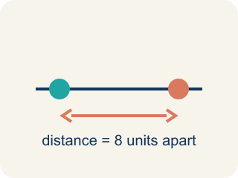
Distance (Distancia) — How far apart two points are. It is never negative.
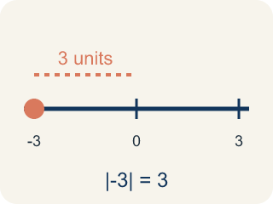
Absolute value (Valor absoluto) — How far a number is from zero.
Horizontal distance (Distancia horizontal) — How far apart two points are going left or right.
Vertical distance (Distancia vertical) — How far apart two points are going up or down.
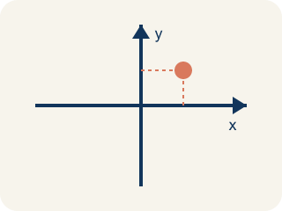
Coordinate plane (Plano cartesiano) — A grid with a line going across and a line going up that cross.
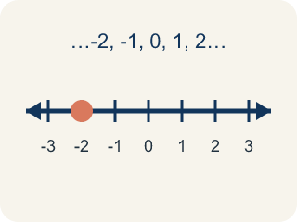
Integer (Número entero) — Whole numbers and their opposites, like -2, -1, 0, 1, 2.

Practice
Show your work. Use the blank space under each problem.
1. What is the distance between (-4, 3) and (2, 3)?
A. 2 units
B. 4 units
C. 6 units
D. 8 units
______________________________________________________________________
2. What is the distance between (5, -2) and (5, 4)?
A. 2 units
B. 4 units
C. 6 units
D. 10 units
______________________________________________________________________
3. Find the perimeter of each rectangle using its vertex coordinates.
Rectangle | Vertices | Width | Height | Perimeter
Rect 1 | (-3, 1), (4, 1), (4, 5), (-3, 5)
Rect 2 | (-2, -4), (6, -4), (6, 2), (-2, 2)
______________________________________________________________________
4. Two points are at (-3, -7) and (-3, 5). What is the distance between them?
A. 12 units
B. 2 units
C. 7 units
D. 8 units
______________________________________________________________________
5. onLevel — Spot the Common Mistake
Step 1 (Read): A student is working on Distance on the Coordinate Plane.
Step 2 (Attempt): They ignored the rule: If points are on the same side of zero, subtract; if they are on opposite sides of zero, add the absolute values.
Step 3 (Check): The answer does not match the math rule from class.
Which step has the mistake? Explain and fix it:
______________________________________________________________________
______________________________________________________________________
______________________________________________________________________
6. The Bank is at (2, 3) and the Library is at (2, 9). How many blocks apart are they?
A. 6 blocks
B. 12 blocks
C. 3 blocks
D. 11 blocks
______________________________________________________________________
7. The Park is at (-4, 5) and City Hall is at (3, 5). How many blocks apart are they?
A. 1 block
B. 7 blocks
C. 12 blocks
D. 5 blocks
______________________________________________________________________
8. The Café is at (-2, 1) and the Gym is at (-2, -4). How many blocks apart are they?
A. 3 blocks
B. 5 blocks
C. 6 blocks
D. 2 blocks
______________________________________________________________________
9. Match each pair of city landmarks to the number of blocks between them.
Item | Answer choices
____ Subway (1, 6) to Tower (8, 6) | D. 5 blocks
____ Market (-3, -1) to Stadium (-3, 7) | C. 6 blocks
____ Bank (2, 3) to Library (2, 9) | B. 8 blocks
____ Café (-2, 1) to Gym (-2, -4) | A. 7 blocks
______________________________________________________________________
10. Sort each block-distance problem by whether you SUBTRACT (same side of zero) or ADD absolute values (opposite sides of zero).
Groups: Same side of zero — subtract | Opposite sides of zero — add absolute values
• School (2, 3) to Library (2, 9) → __________________
• Subway (1, 6) to Tower (8, 6) → __________________
• Park (-4, 5) to City Hall (3, 5) → __________________
• Café (-2, 1) to Gym (-2, -4) → __________________
______________________________________________________________________

Answer Key (Teacher)
1. C. 6 units
Both points have y = 3, so this is a horizontal distance. |2 - (-4)| = |2 + 4| = 6 units.
Watch for: A common mistake in Distance on the Coordinate Plane is skipping the key idea: "If points are on the same side of zero, subtract; if they are on opposite sides of zero, add the absolute values." — always check your work against this rule before you submit.
2. C. 6 units
Both points have x = 5, so this is a vertical distance. |4 - (-2)| = |4 + 2| = 6 units.
Watch for: A common mistake in Distance on the Coordinate Plane is skipping the key idea: "If points are on the same side of zero, subtract; if they are on opposite sides of zero, add the absolute values." — always check your work against this rule before you submit.
3. Find the perimeter of each rectangle using its vertex coordinates.
Rect 1 — Width: 7
Rect 1 — Height: 4
Rect 1 — Perimeter: 22
Rect 2 — Width: 8
Rect 2 — Height: 6
Rect 2 — Perimeter: 28

4. A. 12 units
Same x = -3. Distance = |5 - (-7)| = |5 + 7| = 12 units.
Watch for: A common mistake in Distance on the Coordinate Plane is skipping the key idea: "If points are on the same side of zero, subtract; if they are on opposite sides of zero, add the absolute values." — always check your work against this rule before you submit.
5. onLevel — Spot the Common Mistake
The mistake is in Step 2.
Correct work: Follow the key idea: If points are on the same side of zero, subtract; if they are on opposite sides of zero, add the absolute values.
6. A. 6 blocks
Same x = 2, so the segment is vertical. Distance = |9 - 3| = 6 blocks.
Watch for: A common mistake in Distance on the Coordinate Plane is skipping the key idea: "If points are on the same side of zero, subtract; if they are on opposite sides of zero, add the absolute values." — always check your work against this rule before you submit.
7. B. 7 blocks
Same y = 5, so the segment is horizontal. The points are on opposite sides of zero, so add the absolute values: |-4| + |3| = 4 + 3 = 7 blocks.
Watch for: A common mistake in Distance on the Coordinate Plane is skipping the key idea: "If points are on the same side of zero, subtract; if they are on opposite sides of zero, add the absolute values." — always check your work against this rule before you submit.
8. B. 5 blocks
Same x = -2, so the segment is vertical. The points are on opposite sides of zero: |1| + |-4| = 1 + 4 = 5 blocks.
Watch for: A common mistake in Distance on the Coordinate Plane is skipping the key idea: "If points are on the same side of zero, subtract; if they are on opposite sides of zero, add the absolute values." — always check your work against this rule before you submit.
9. Matches:
Subway (1, 6) to Tower (8, 6) → 7 blocks
Market (-3, -1) to Stadium (-3, 7) → 8 blocks
Bank (2, 3) to Library (2, 9) → 6 blocks
Café (-2, 1) to Gym (-2, -4) → 5 blocks

10. Correct groups:
School (2, 3) to Library (2, 9) → Same side of zero — subtract
Subway (1, 6) to Tower (8, 6) → Same side of zero — subtract
Park (-4, 5) to City Hall (3, 5) → Opposite sides of zero — add absolute values
Café (-2, 1) to Gym (-2, -4) → Opposite sides of zero — add absolute values

